Application of 'Air Fluorine and Ground Water' Heat Pump Technology in China
- Overview

1.1 'Air Fluorine and Ground Water' heat pump dual-supply system
The common heating-cooling dual-supply system of air-source heat pump includes the air-source heat pump water system (also called "household water unit" heat pump dual-supply system or the "feed water - waste water" heat pump dual-supply system) and the air-source multi-connect air conditioner (heat pump) water heating system (also called "Air Fluorine and Ground Water" heat pump dual-supply system).
The household water unit has a long history of development and mature technology. With early market presence, it is currently a dominant player in the air-source heat pump dual-supply cooling and heating market, with American brands holding a significant market share. The relatively complex installation process during the early development stage of the housing water unit, the highly demanding anti-freezing measures, and the occasional water leaks, water-soaked roofs, and other accidents undermined some consumers' and distributors' trust of the products. As a result, housing water units disappeared from the market after 2005. Fortunately, their shortcomings have been rectified in recent years with the optimization of products and technologies and the deepening of sales channels.
In 2018, the "Air Fluorine and Ground Water" heat pump dual-supply system integrating a "fluorine system" for cooling and a "water system" for heating was launched into the Chinese market, referred to as the "Air Fluorine and Ground Water" system in short. Integrating the advantages of being stable, energy-saving, easy usage, and intelligent among others, the system has become much popular among high-end users since its launch in the market. With the continuous boom of the heat pump dual-supply cooling and heating market, the "Air Fluorine and Ground Water" system further integrated the fresh air and heat recovery systems in 2021 to support air conditioning, floor heating, hot water, air purification, and dehumidification functions at the same time.

1.2 Characteristics of the 'Air Fluorine and Groundwater' heat pump products
The main technical characteristic of the "Air Fluorine and Ground Water" heat pump dual-supply system is its dual purposes. In summer, the fluorine system is used as a cooling source for air conditioners, and in winter, the water system is used as a heating source for end equipment such as ground radiator, highlighting a perfect combination of the fluorine and water systems. In summer, the air conditioner adopts the refrigerant end, and in the winter, the ground radiator (or heat sink in a small number of renovated projects) is generally used as the end equipment. During the transitional season or intermittent heating periods, the refrigerant end is used in combination with the purification system to become a multi-purpose home comfort system for air conditioning, heating, and dehumidification, and air purification. Compared with other heating types such as electric heating and gas heating, the "Air Fluorine and Ground Water" system is playing an increasingly prominent role in empowering a green environment and realization of the "dual-carbon" goals.
The "Air Fluorine and Ground Water" system derived from the air-source multi-connect air conditioning unit and the household water unit has dual advantages of both. Its indoor unit adopts a multi-connect form, with refrigerants charged via seamless copper tubes to avoid water leaks and water-soaked roofs. Moreover, its indoor unit is based on a multi-connect unit that has a mature technology, a diversity of models, free and flexible control, and efficient operation of part of the loads. The heating end usually adopts ground radiation. The human body temperature is higher at the head and lower at the feet. The general split-type air conditioners or the central air conditioners use fan coils supply air via top convection. The hot air is relatively light and easy to gather in the upper part of the room, resulting in the unbalanced heat distribution, namely "warm at head and cold at feet". Ground radiator heating disperses heat from bottom to top, making people "cold at head and warm at feet", which is more comfortable.
The "Air Fluorine and Ground Water" heat pump dual-supply system currently comes in two types, namely the split type and the integral type. The split type is composed of an outdoor main unit, an indoor unit, and a water module, while the integral type is composed of an outdoor main unit with a built-in water module and an indoor unit.
Figure 1 shows the heating principle of the "Air Fluorine and Ground Water" system. The outdoor unit drives the inverter compressor with a small amount of electricity to absorb a large amount of low-temperature heat from the outdoor air and convert the heat into high-temperature heat through the reverse Carnot cycle. The refrigerant and the water heat exchanger help produce hot water of around 55°C at the highest. The hot water is then driven by a circulating water pump to flow in the pipes of the floor heating (radiator) end equipment and warms up the indoor air through heat transfer such as ground radiation. In cold areas, an intermediate economizer or a flash evaporator among other technical solutions may be added to the "Air Fluorine and Ground Water" system to inject refrigerant of medium temperature and medium pressure to the enhanced vapor injection compressor to ensure enough heat.
Air-source heat pump unit
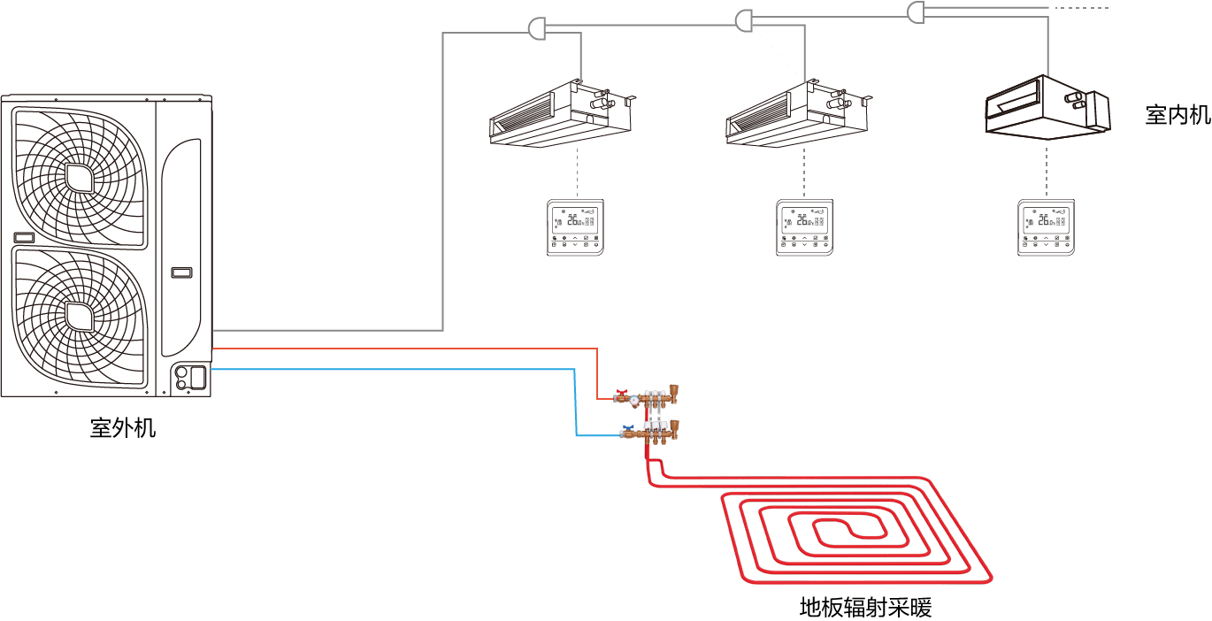
Radiant floor heating
Indoor unit
Air source heat pump unit
Figure 1a Schematic diagram of the "Air Fluorine and Ground Water" heat pump dual-supply system
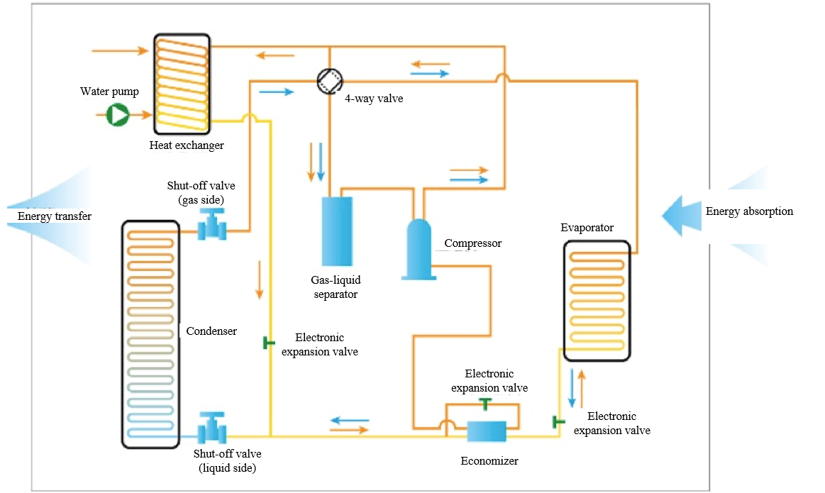
Figure 1b Schematic diagram of the outdoor unit of the "Air Fluorine and Ground Water" dual-supply heat pump

  - 'Air Fluorine and Ground Water' heat pump applicable areas
Multiple provinces in North China, represented by Beijing, successively launched coal-to-clean energy policies in early 2016. These policies fueled the rapid development of the gas water heater and heat pump markets. The ground radiation and other heating methods gain popularity as the economic level goes up and residents' demand for comfort and heating performance rises. Gas water heating was the first to enter the market. As the gas cost increases, the "air conditioner + floor heating" heat pump dual-supply heating and cooling product receive gradual recognition from the market, unlocking a development opportunity for the heat pump heating market.
The "Air Fluorine and Ground Water" heat pump dual-supply system is widely applicable to hot-summer/cold-winter zone, cold zone B and hot-summer/warm-winter zone A, especially in the Yangtze River Basin such as Jiangsu, Zhejiang, Shanghai, Anhui, and Hubei regions. Generally, the Yangtze River Basin has no central heating system. But as the living standards improve and consumers' consumption power and awareness increase, their demand for heating in winter gradually rises, creating an inherent advantage for the popularity of the "Air Fluorine and Ground Water" system.
The market share of air-source heat pump dual-supply cooling and heating systems in East China reached as high as 49.8% in 2021, an increase of 27.4% compared with 2020. Many manufacturers put more resources into East China. In addition, the overall market share of the dual-supply system market in North China, Central China, and Southwest China was higher than 10%. Due to constraints such as climate and consumption levels in Northwest, Northeast, and South China, the overall market share was still small but growing at an increasing rate. The heat pump dual-supply cooling and heating system is highly subject to the impact of the outdoor temperature, and its development in northwest and northeast China, where the temperature can be as low as -30°C during the heating season, has been limited to a great extent. However, in South China, where the temperature in the heating season is usually above 10°C, the demand for heating has been lower. See Figure 2 for details.

Figure 2 Regional market share and growth rate of air-source heat pump dual-supply cooling and heating system in 2021
The real estate sector, especially high-end villas and independent houses in rural areas, is the main market of air-source heat pump dual-supply cooling and heating units, which are among the top options for heating in winter and air conditioning in summer. In addition, the policies encouraging ultra-low energy buildings and green construction in Jiangsu, Zhejiang, and Shanghai regions in the past two years have further promoted air-source heat pump dual-supply cooling and heating units. Meanwhile, how to select, design, install, and use the air-source heat pump dual-supply cooling and heating system more scientifically and reasonably in energy-efficient buildings and green construction requires the joint efforts from all in the industry to make the product more comfortable, more energy-efficient and more environmentally friendly.

- Performance analysis

2.1 Main advantages of the 'Air Fluorine and Ground Water' heat pump dual-supply system
The "Air Fluorine and Ground Water" heat pump dual-supply system elevates the comfort level of hot water ground radiant heating on the basis of the multi-connect air conditioners, and draws on the advantages of the fluorine system and the water system. It is advantageous in terms of the level of comfort, intelligent operation, reliability, low carbon emissions, and energy conservation, among others. The application scenario is shown in Figure 3. The advantages of the "Air Fluorine and Ground Water" system are as follows.
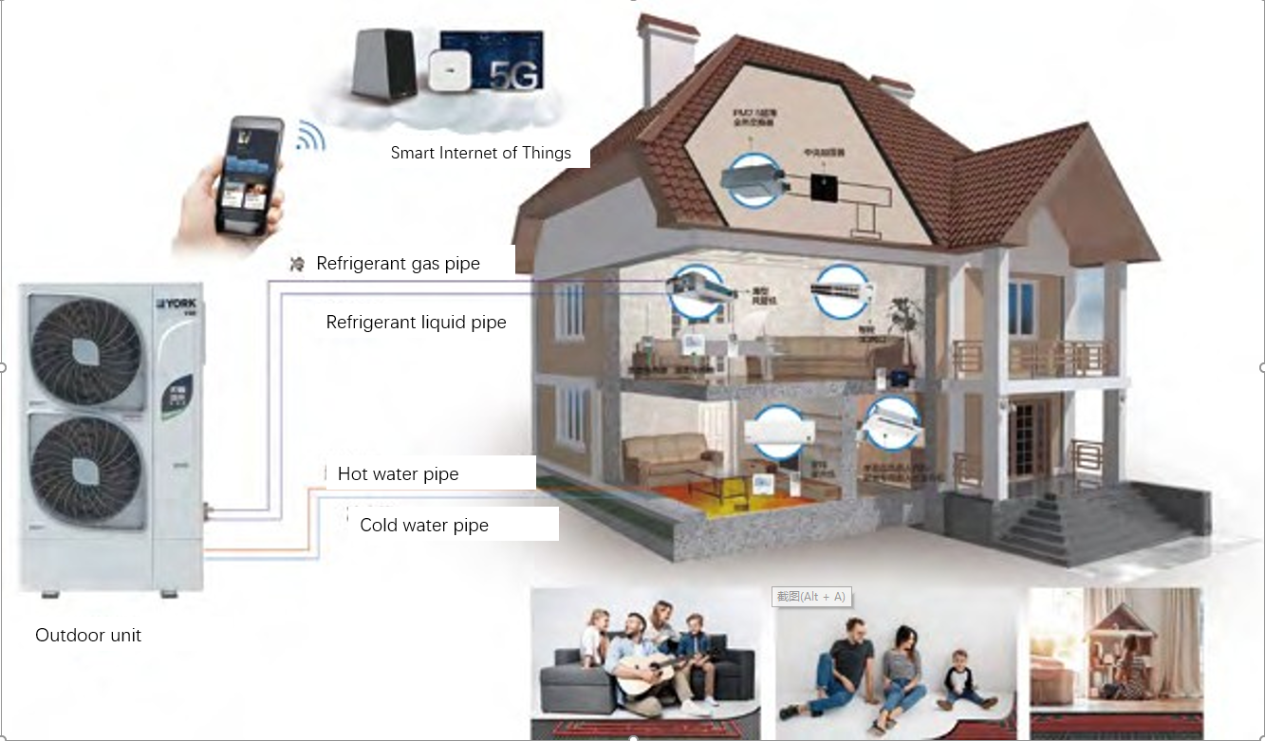

Figure 3 "Air Fluorine and Ground Water" dual-supply smart solution
In terms of technology, the industry has developed many technologies such as low-temperature heating, anti-freezing protection, and anti-leakage protection based on the air-source heat pump dual-supply cooling and heating market feedback to ensure products' stable operations. For example: (1) An enhanced vapor injection or strengthened liquid injection compressor is equipped with the adaptive defrosting technology to ensure reliable heating performance of the outdoor unit at low temperature. (2) The water module uses the sleeve-type heat exchanger with better anti-freezing and anti-impurity performance and connects it with the compressor vent to eliminate freezing during the unit operations. Meanwhile, water pump operation, heat pump operation, and anti-freezing app reminders are adopted to ensure unit stability at all times. (3) The solution has undergone 72-hour simulation of cooling, rainfall, strong wind, freezing rain, high temperature and humidity and other harsh conditions to ensure the quality of the outdoor unit for a long time; (4) Key components are imported from abroad to improve the product stability; (5) The indoor unit is protected by a built-in float switch and a condensate pump for real-time monitoring and powerful drainage to eliminate any hidden risks of water leakage; (6) The design process is standardized, the quality is reliable, the system runs stably, and the construction is simple.
From the consumers' point of view, there is a saying in Chinese medicine that "keep the feet warm and the head cool", advocating that people should keep their feet warm and their head relatively cool. The ground radiant heating emits heat bottom up and the heat gradually decreases from the ground to the roof. The air conditioner cooling emits cool air overhead and the temperature gradually increases from the roof to the ground, which is more in line with the health preservation principle of traditional Chinese medicine. The "Air Fluorine and Ground Water" system highlights warmer air in the lower part and cooler air in the top part, complying with the concept of health safeguard.
From product development's point of view, the solution adopts a DC variable-frequency heat pump system to precisely control the heating and cooling effects according to real-time loads and the demand, enabling highly efficient and stable operations in both heating and cooling scenarios. The indoor relative humidity is an important indicator of comfort, and there are two main methods to maintain its stability, namely dehumidification and humidification. Dehumidification is where the advantage of the "Air Fluorine and Ground Water" heat pump system lies. In the "dehumidification + floor heating" mode, the indoor unit plays the main dehumidifying role and the indoor heat and the waste heat generated by the outdoor unit are transported to the indoor room through the water pump to dehumidify the air without cooling it. In recent years, people have started to set higher indoor temperature in winter for a higher level of comfort, reducing the relative humidity and creating the urgent demand for humidification, especially for the dry northern China regions. The "Air Fluorine and Ground Water" system draws fresh air, humidifies the fresh air with a total heat exchanger and a central humidifier, and humidifies the indoor air through internal circulation. It can be equipped with a fresh air ventilator, a total heat exchanger, a built-in coarse filter, a PM2 high-efficiency filter, and an activated carbon filter to remove harmful gases such as SO₂ and NO₂ and create a healthy and clean breathing environment.

2.2 Comparison with gas water heater + air-cooled multi-connect air conditioner
Currently, the domestic household heating includes four forms: gas water heater, air-source heat pump, electric heating, and solar heating, of which the former two account for the largest market share. For the "cooling in summer and heating in winter" solutions much needed by users, the common ones available in the market include gas water heater with a multi-connect air conditioner, household water unit heat pump dual-supply system, and the "Air Fluorine and Ground Water" heat pump dual-supply system.
The following is a comparison between the "Air Fluorine and Ground Water" system and the gas water heater combined with an air-cooled multi-connect air conditioner. The gas water heater heats water with the heat released by the combustion of combustible gas and is applicable to areas with sufficient natural gas and a low cost, such as Tianjin, Chengdu, and Chongqing. To ensure the air conditioning and refrigeration supply, an additional multi-connect air conditioning unit is usually needed, that is, two independent systems are required. The "Air Fluorine and Ground Water" heat pump dual-supply system realizes cooling and heating functions with one system. Its cooling performance is the same as that of the multi-connect air conditioning unit, and the difference between the two is largely in heating. The gas water heating and the "Air Fluorine and Ground Water" heat pump dual-supply system heating have great differences in comfort, intelligent level, stability, and energy cost. The specific analysis is shown in Table 1.
Table 1 Comparison of gas water heater with a multi-connect unit and the "Air Fluorine and Ground Water" system
Ground radiation  Heating temperature | The inlet water temperature of ground radiation heating needs to be 35-45ºC, and the outlet water temperature of gas heating furnace should be 55-60ºC. In areas with poor water quality, scaling is easy to achieve. Generally, a coupling tank is required to adjust the water temperature. | The outlet water temperature of the "Air Fluorine and Ground Water" system is 35-45ºC, suitable for ground radiation heating.
Indoor noise | Noise of gas heating furnace ≤ 45dB(A) | Minimum noise of indoor unit: 17dB(A)
Design service life | Eight years | 15-20 years
System stability | Gas is flammable and contains safety hazards in addition to complicated daily maintenance. Moreover, the "gas source" is often insufficient during the peak heating seasons. | Intelligent control and operations 24 hours * 360 days, requiring no manual care, safe and reliable.
Installation | Two sets of systems need to be installed to address cooling and heating needs, making design and installation complicated and occupying a larger space. | One system, easy to install
Low-carbon and environmentally friendly | With emissions of CO₂, CO waste gas and harmful gases | Zero emissions due to the electricity and air energy used for heat generation
Operating cost | High gas prices and high operating costs | Highlighting a high energy efficiency in the heating load of the air-source heat pump, with a low operating cost. Taking Changsha as an example, its operating cost is at least 42% lower than that of a gas water heater under the same heat demand.
Intelligent temperature control | The water temperature is controlled within ±1ºC. | Indoor temperature can be adjusted within a range of ±0.5ºC.

2.3 Comparison with the household water unit system
Compare the "Air Fluorine and Ground Water" system with a household water unit. The household water unit features an "air water and ground-water" system. The air-source heat pump unit acts as the cooling and heating source, and the fan coil unit and ground radiation act as the indoor terminal system to transmit refrigeration/heating energy to the indoors via water for "fan coil unit for refrigeration + ground radiation for heating". In view of the difference between water system refrigeration and fluorine system refrigeration, the system form, characteristics, design and construction of the two types of systems also have great differences. See Table 2 for details.
Table 2 Comparison of household water unit and "Air Fluorine and Ground Water" system
Content |  | Household water unit | "Air Fluorine and Ground Water"
Indoor unit | Fast refrigeration | The outdoor unit and the fan coil unit are connected via a water pipe and the water indirectly evaporates (evaporation temperature at 12-15ºC) | The refrigerant in the indoor unit directly evaporates (evaporation temperature at 5-7ºC), and the unit is equipped with a frequency conversion starting device to quickly reach the rated capacity output of the unit for faster cooling performance.
 | Precise dehumidification | No humidity targets can be set for conventional fan coil units. | The indoor unit is equipped with a dehumidification sensor component for real-time monitoring, supporting automatic dehumidification, low-temperature dehumidification, precise dehumidification, and non-cooling dehumidification functions, which can easily address the monsoon season and the humid weather.
 | Service life | The design service life of the conventional fan coil unit is eight years. | The design service life of the indoor unit is 15-20 years.
 | Opening diameter and ceiling height | The conventional fan coil unit has a large opening for the water connection pipe, without a condensate water drainage pump and with a high ceiling. | The refrigerant pipe of the indoor unit has a small opening and the standard condensate drainage pump has a pump head of 1,200mm, which enables quick and strong water drainage without lowering the ceiling to save the ceiling space.
Outdoor unit | Pump frequency conversion | The conventional products use fixed-frequency water pumps, while high-end products use variable-frequency water pumps. | Variable-frequency water pumps are widely used to adjust the heating loads according to the indoor temperature and the water flow.
System reliability |  | Buffer water tank, soft connection, gate valve, filter and other pipe connection valves and parts need to be repaired later. | The indoor unit has a simple refrigeration loop and well-developed design and installation methods. It has specially designed defrosting functions for floor heating systems, and the water circulation system does not participate in defrosting, without buffer water tanks and supports uninterrupted hot water supply to ground heating.
Maintenance cost |  | Professional maintenance personnel are required to provide maintenance and use guidance. Generally, merchants reserve 7%-10% of the after-sales maintenance fee for later maintenance. | The outdoor unit has a high degree of interconnection and is freely turned on or off instantly, without special maintenance.

3. Conclusion
The market share of the "Air Fluorine and Ground Water" heat pump dual-supply systems has skyrocketed in China, and more and more users have started to install this integrated heating and cooling solution that boasts high energy conservation and superior comfort. With the upgrading of products and the accumulation of designers' and manufacturers' experience, it is believed that the market will further expand in the future, and more people will devote themselves to this booming sector.
The "Air Fluorine and Ground Water" heat pump dual-supply system not only meets the needs of ordinary houses and villas, but can also be extended to ultra-low energy consuming (near-zero energy) buildings, hotels, penthouses and other projects due to its larger capacity of ceiling-vent air products. With the improvement of products and services, such as the launch of the "Air Fluorine and Hot Water" products, the upgrading of consumption and the development of photovoltaic heat pump systems will help achieve the goal of carbon neutrality, and the heat pump dual-supply systems will also embrace wider application.

