Advanced round-tube, plate-fin (RTPF) heat-exchanger coils contribute to the high efficiency of heat pumps
Nigel Cotton^{a,} Yoram Shabtay^{b}
ªInternational Copper Association, Avenue de Tervueren, 168 - box 10, 1150 Brussels, Belgium
^{b}Heat Transfer Technologies LLC, 15 Glenbrook Drive, Prospect Heights, IL 60070
Abstract
Smaller-diameter, inner-grooved copper tubes can be found in a myriad of heat-pump products. Commonly referred to as “MicroGroove coils,” these advanced heat-exchangers are well suited for use in heat pumps. They are more efficient and more compact and contain a smaller volume of refrigerant compared to earlier generations of coil designs. MicroGroove coils are suitable for refrigerant-to-air heat exchangers, including evaporators and condensers as well as gas coolers. This paper will present examples of how these coils are used in diverse products such as clothes-drying heat pumps and heat pumps for residential heating and cooling. Once the smaller-diameter copper tubes are interlaced with aluminum fin plates and mechanically expanded, the ruggedness of the resulting round tube plate fin (RTPF) heat exchangers is remarkable. Manufacturing equipment and techniques that allow OEMs to produce these coils in volume will be described as well as sophisticated simulation software for optimizing tube circuitry and fin designs for maximum efficiency. These various factors combined are contributing to an atmosphere of creativity and innovation, increasing the energy efficiency of heat pumps while reducing the use of high-GWP refrigerants.

© 2017 Stichting HPC 2017.
Selection and/or peer-review under responsibility of the organizers of the 12th IEA Heat Pump Conference 2017.

Keywords: Copper; tubes; microfins; microgroove, microchannel, RTPF coils, pressure expansion
- Introduction
Manufacturers are highly motivated to develop heat exchangers that satisfy three often contradictory criteria: low refrigerant-charge, high energy-efficiency and low cost. Smaller diameter copper tube heat exchangers help manufacturers reach all three of these objectives.
For many applications, coil designs have been optimized for traditional tubes. The term “traditional” in this context typically refers to copper tubes with an outer diameter of 9.52 mm (3/8 inch), a size widely used in past decades. Today, the traditional tube diameter is no longer the benchmark for coil design. Improvements in CFD modeling, system optimization and correlations with laboratory experiments as well as advances in manufacturing have opened the door to widespread adoption of smaller-diameter copper tubes in appliances.
In this paper, important advances in the manufacture, design and use of coils made from smaller diameter copper tubes are summarized with special reference to the application of these coils in heat pump appliances.
- Typical Applications
For outdoor heat pump condensers, the industry has been gradually migrating to smaller diameter tubes. Figure 1 shows a coil made from seven millimeter diameter copper tubes, a size commonly used in outdoor heat pump coils. The use of even smaller diameter tubes is expected to increase as manufacturing methods improve.
Figure 2 shows a coil made from five millimeter copper tubes as designed for use in a clothes dryer heat pump.
Figure 3 shows a coil made from five millimeter copper tubes as designed for use in a R744 condenser.

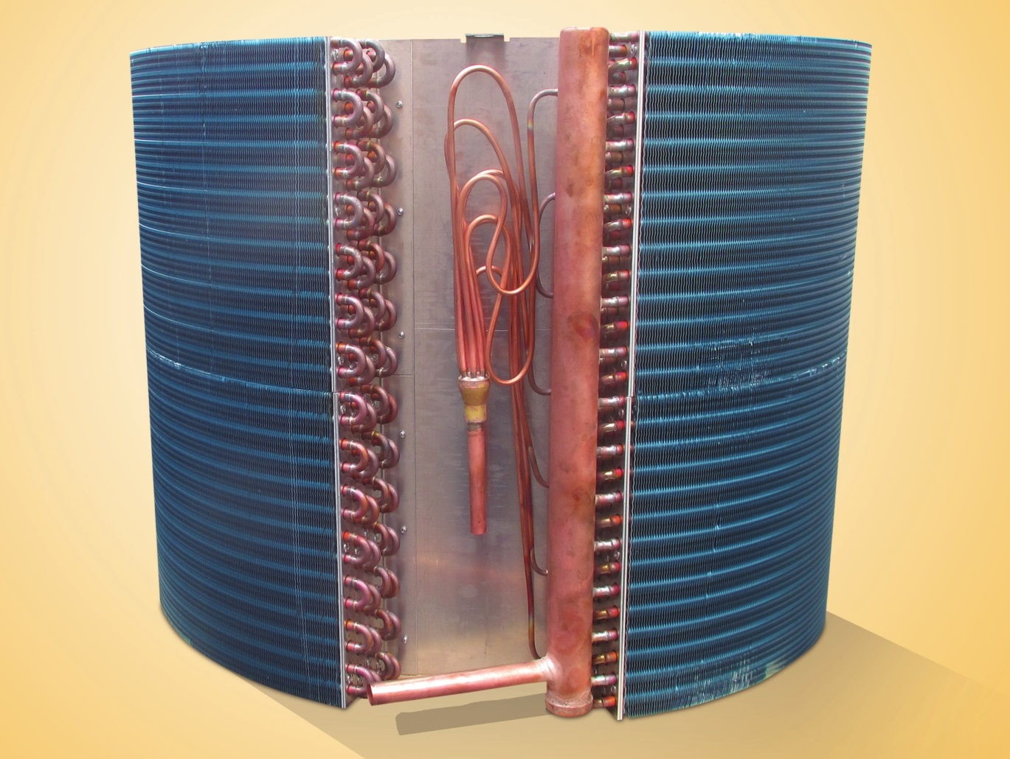
Fig. 1. Outdoor coils for residential heat pump are migrating towards smaller diameter copper tubes, to increase efficiency and reduce refrigerant volume. This MicroGroove coil uses 7-mm outer diameter copper tubes. (Photograph courtesy of Lordan.)

Fig. 3 This MicroGroove coil made with 5 mm O.D. copper tubes serves as a condenser in R744 applications (Image courtesy of Spirotech)

F ig. 2. This MicroGroove coil made with 5 mm O.D. copper tubes serves as the condensing unit for a heat pump clothers dryer. (Image courtesy of Spirotech.)

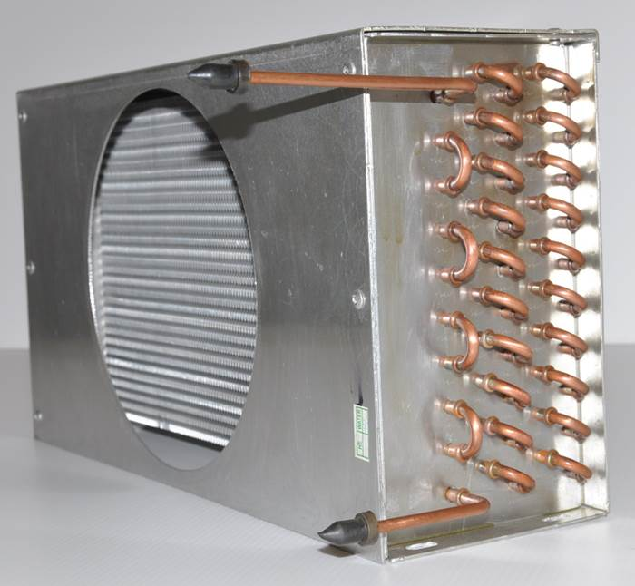
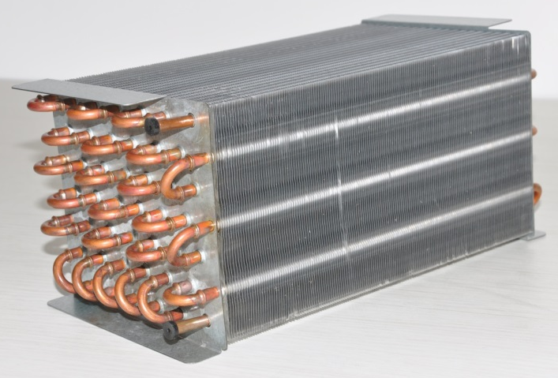
- Advances in Manufacturing
The manufacture of RTPF coils from copper tubes and aluminum plate fins requires that the copper tubes be expanded from the inside until they make contact with the collared aluminum fins. Typically the copper tubes are deformed beyond the yield stress (that is, they are subject to plastic deformation) whereas the aluminum fins are elastically strained. This provides a tight interference fit that conducts heat well between the two metals.
A new pressure expansion technology from Burr OAK Tool Inc. (BOTI) promises to improve throughput and yield in the manufacture of heat exchanger coils from smaller diameter copper tubes. Joint research was conducted by Optimized Thermal Systems (OTS) and BOTI on the effects of manufacturing methods on tube enhancements [1]; and a paper delivered at the 2016 Purdue Conferences on noninvasive pneumatic pressure expansion provided test results on this important new manufacturing method [2]. The challenges of applying bullet methods to expand smaller diameter tubes was outlined and compared with alternative methods such as Limited Shrink Tension Expansion, Zero Shrink Tension Expansion and Tubular Hydro Expansion (Figs. 4-7).
The new pressure expansion equipment from BOTI uses high pressure air as the expansion fluid. Noninvasive pressure expansion is inherently a zero shrink process. The Lévy-Mises equations that describe plastic flow in material show that a tube experiences zero axial strain while pressure is applied to expand the tube diameter plastically. The internal pressure that expands the tube diameter also places the tube in tension; and, in fact, the tension is the exact amount needed to keep the tube from shrinking.
This approach allows for quick filling of the tubes while maintaining the cleanliness of the coils. The use of water or other liquids would require post-process cleaning, which is undesirable in the manufacture of coils for air-conditioners, heat pumps and refrigeration equipment.
Coils made using mechanical methods were compared with coils made using the new pressure expansion method with respect to visual inspection, physical testing of heat exchanger strength and construction, measurement of heat exchanger dimensions, and physical testing of heat transfer performance. Most strikingly, the pressure expansion resulted in more consistent expansion of the tubes. The standard deviation of the final tube diameter was only 0.016 mm for the pressure expanded coils compared to 0.029 for the mechanically expanded coils.
The pressure expansion method provides the following benefits:
- No damage to internal enhancements
- Improved contact between the tubes and the fin collars
- Better control over the final dimensions of the tubes
The use of high pressure air for tube expansion provides a level of quality control by identifying any defective tubes early in the manufacturing process before subsequent brazing and leak testing. The equipment was designed with multiple safety features as described in a recent video from Burr Oak Tool Inc. which can be viewed on the Burr Oak Tool YouTube channel. Furthermore, a new white paper is now available from Burr Oak addressing the issue of safety [3]
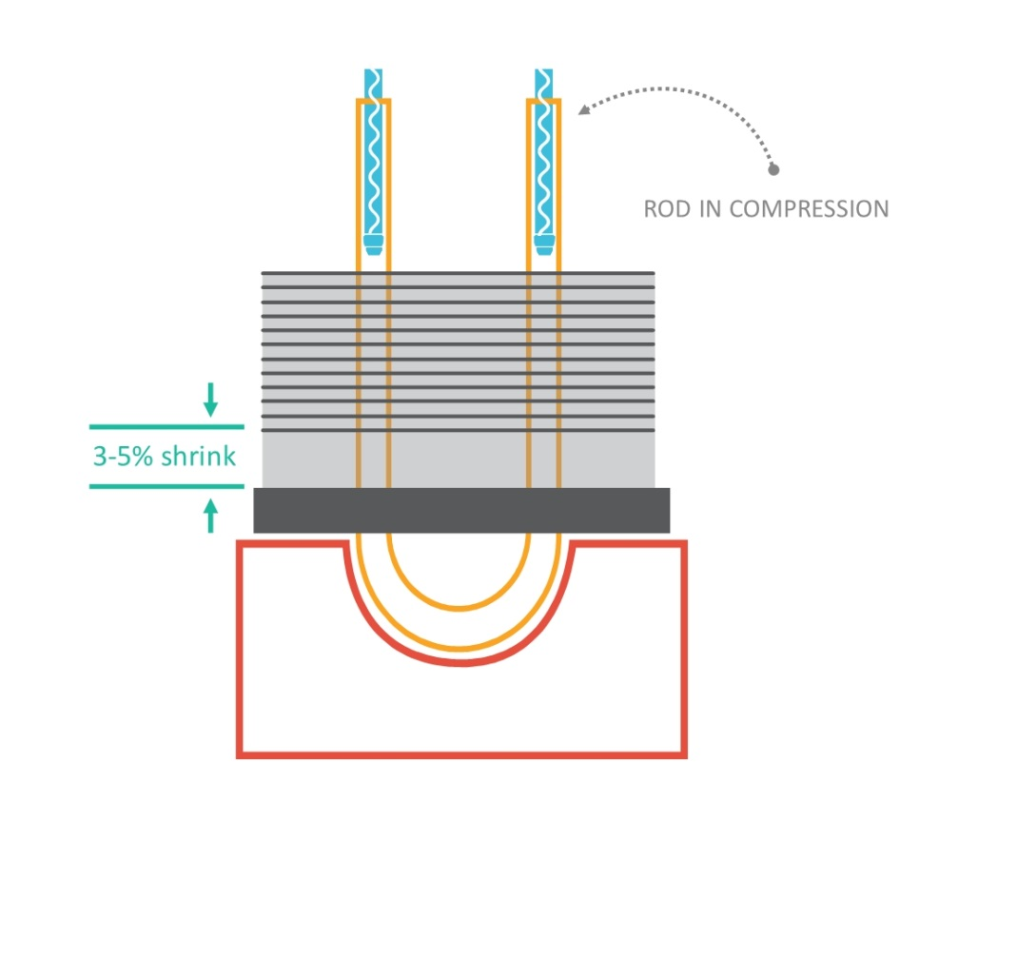
Fig. 4. The bullet expansion method results three to five percent shrinkage, which has to be cared for during subsequent manufacturing steps. Courtesy of BOTI.
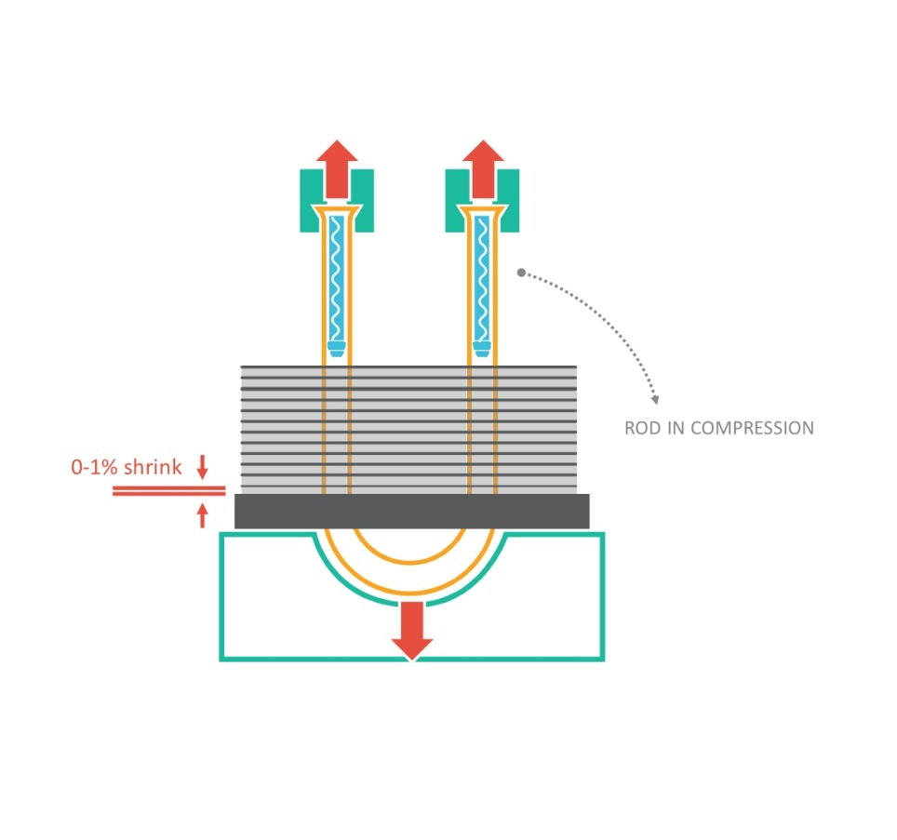
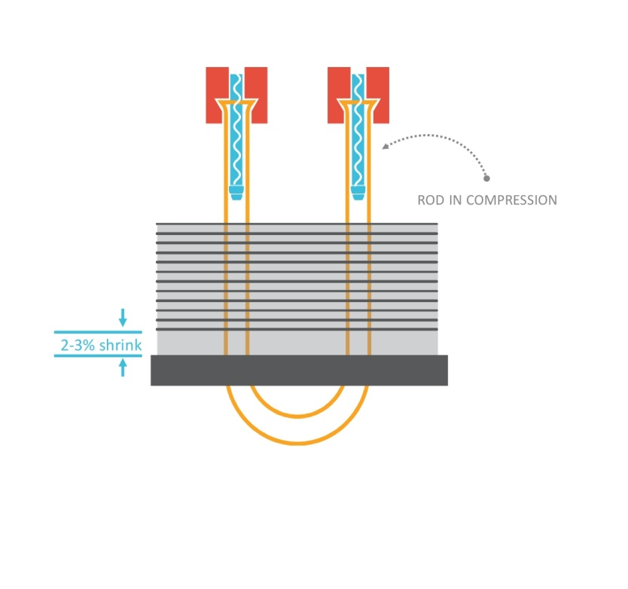
Fig. 6. The limited shrink tension method places the tube in tension with enough force to counteract the shrinkage but some shrinkage can still occur. Courtesy of BOTI.
Fig. 5. The tension expansion method reduces shrinkage by allowing the tube to stretch as the bullet is applied. Courtesy of BOTI.
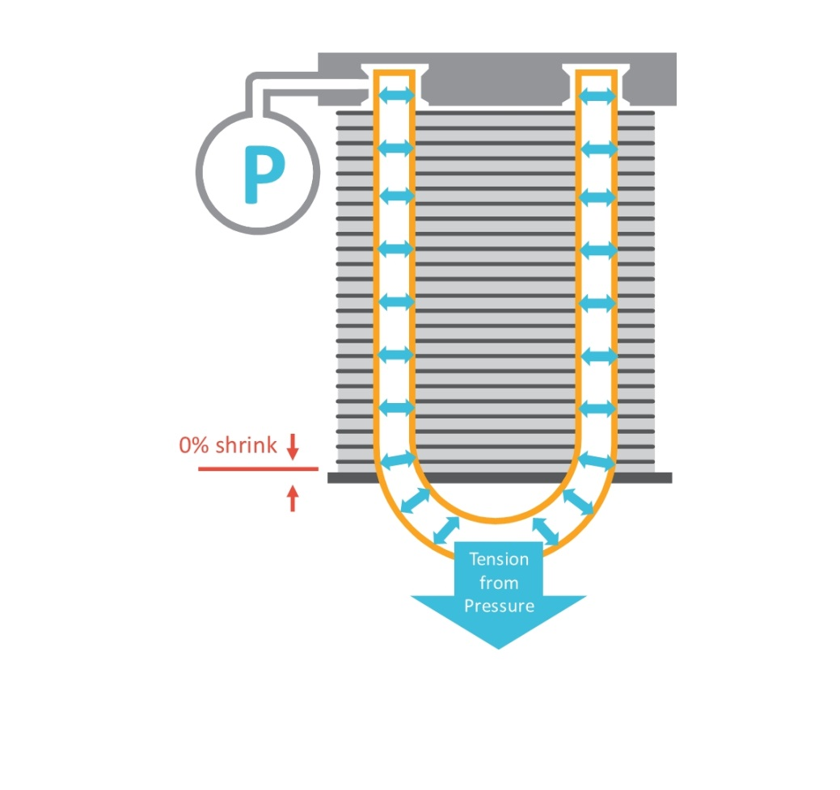
Fig. 7. The noninvasive pressure method is inherently a zero-shrink process. Courtesy of BOTI.
- Computer Simulations
  - Airside Heat Transfer
Airside heat transfer around smaller diameter tubes can be modeled with unprecedented accuracy, opening the door to new, more energy efficient heat exchanger designs.
Airflow around smaller diameter tubes faces less resistance than airflow around traditional tubes. Research supported by the International Copper Association (ICA) and conducted by Optimized Thermal Systems, Inc. (OTS) compares the performance of slit fins and louvre fins for smaller diameter (3 mm to 5 mm) copper tubes [4, 5].
Previously only the largest OEMs could afford to perform such coil optimization through CFD modeling. Designers were guided by general principles, or “rules of thumb,” and fin designs were not optimized for smaller diameter tubes. Limited progress was made in China by a research consortium that used a knowledge-based evolution method (KBEM) to eliminate unfeasible or impractical designs before the simulations are performed, allowing for a more efficient sampling of the design space [6].
Now, thanks to the Center for Environmental Energy Engineering (CEEE) at the University of Maryland and OTS, techniques for optimizing coil designs are available to users of CoilDesigner®, a highly customizable software tool that allows designers to simulate and optimize the performance of heat exchangers [7]. OTS works with coil designers around the globe to optimize heat exchanger geometry, including the use of smaller diameter tubes. CoilDesigner includes the latest heat transfer and pressure drop models published in the open literature and users also can plug-in proprietary models. OEM users can shorten product development costs and quickly bring products to market.
  - Refrigerant Side Heat Transfer
Simulation software uses correlations developed for both airside and refrigerant side heat transfer, building on the research results from many laboratories around the globe. Thus, the prediction accuracy of such simulations depends on the availability and accuracy of these correlations.
Seminal research was performed at the Institute of Refrigeration and Cryogenics of Shanghai Jiao Tong University [8]. Now laboratory research results are also available for new low-GWP refrigerants in smaller diameter copper tubes. In particular, laboratory experiments on MicroGroove tubes were conducted at three universities: the University of Padova, Padova, Italy [9, 10]; Tokyo University of Marine Science and Technology [11]; and Kyushu University, Fukuoka, Japan [12].
Such research provides predictive correlations that can be used to simulate the performance of coil designs that use smaller diameter copper tubes with a variety of inside-the-tube enhancements (i.e., microfins) and low- and ultra-low GWP refrigerants.
According to the Padova group, in reference to previous research in this field, “the literature about smaller diameter microfin tubes (i.e., inner diameter lower than 6 mm or so) is poor if compared with larger tubes.” They aptly dubbed these “mini microfin-tubes” in contrast to traditional (larger diameter) microfin tubes. These researchers measured flow boiling heat transfer and pressure drops inside copper tubes with internal enhancements [9]. In this first paper, the copper tubes had an outer diameter (OD) of 5 mm and the refrigerant was R134a. The saturation temperature was 10 °C. The vapor quality was varied from 0.1 to 0.95; the mass velocity from 100 to 800 kg/m²s, and the heat flux from 15 to 90 kW/m². As expected, the dominant mechanisms are convective boiling at low heat fluxes, and two-phase forced convection at high heat fluxes. The authors concluded that the results highlight the promising heat transfer capabilities of mini microfin tubes during flow boiling. Looking forward, they state that “additional heat transfer measurements with different tube diameters, different helical geometries, and different type of refrigerants are surely needed.”
In a second paper, the Padova group also measured flow boiling heat transfer and pressure drop for an ultralow-GWP HFO1234ze(E) refrigerant inside smooth tubes having an OD of 4 mm [10]. The heat transfer coefficients for the HFO were similar to those for HFC134a at the same operating conditions but the pressure drops were 10 to 25 percent higher for the HFO. According to these authors, the heat transfer measurements confirm that HFO1234ze(E) is a very promising low-GWP candidate for HFC134a replacement.
The Tokyo research measured pressure drops and evaporative heat transfer coefficients for R32 refrigerant passing through 4 mm OD copper tubes with a broad range of internal enhancements, including “microfin” heights of 0.1 mm and 0.2 mm [11]. Measurements were made at saturation temperature of 15 °C with mass velocity ranging from 50 to 400 kg/m²s and heat flux from 5 to 20 kW/m².
Meanwhile, the Kyushu group measured heat transfer coefficients for mixtures of R32 with HFOs [12]. This research is especially important because it provides performance data for different compositions of the refrigerant mixtures. “Temperature glide” is known to compromise performance in R32/HFO mixtures compared to single components (i.e., R32 or HFO alone). The Kyushu results provide predictive correlations including the effects of microfins for these refrigerant blends, which are likely to play an important role in future air conditioning and refrigeration systems. The microfins in the 4-mm diameter copper tubes had heights of 0.26 mm.
- Easy Drainage and Cleaning
An advantage of round tube plate fin (RTPF) coils is ease of cleaning and good condensate drainage. The plate fins in RTPF coils are typically vertically oriented and water drains easily from the top to the bottom of the sheets. The tubes penetrate the sheets at right angles and water can easily flow around them. The same holds true for RTPF coils made from smaller diameter copper tubes. There may be more tubes penetrating the plate fins but water flows easily around the smaller diameter tubes.
The open structure of a round tube plate fin (RTPF) is a major advantage of MicroGroove heat exchangers compared to aluminum microchannel heat exchangers, which is why MicroGroove heat exchangers are commonly used in the outdoor evaporators of heat pumps especially in colder climates where frosting may be an issue.
A wavy fin is a plate fin with no holes and so drains better. Wavy fin designs are found to be more effective for heat pumps where the outdoor evaporators may be subject to frosting and for refrigeration equipment where frosting and condensation cancels the advantages of slit and louvre type fins due to the clogging of the openings.
Also, enhanced fins such as slit or louvered fins aggravate the dust accumulation in the condensers of refrigerated display cabinets [13]. Condensers in display cabinets are especially prone to dust accumulation because they are positioned close to the floor.
Supported in part by International Copper Association, researchers at the Institute of Refrigeration and Cryogenics, Shanghai Jiao Tong University, conducted research to examine the feasibility of replacing 9.52 mm copper tubes with 5 mm diameter tubes in the condensers of refrigerated display cabinets [14]. Wavy fins were chosen for this application because of considerations about dust accumulation.
The fin structure was selected by theoretical analysis and the flow path of a 5-mm-diameter-tube heat exchanger was analyzed using a heat exchanger simulation tool to find a suitable balance between heat transfer and pressure drop. The simulation results suggest that the cost of the condenser could be reduced by 26 percent using the 5 mm tube with the performance being the same as the 9.52 mm prototype. The experimental data validated the simulation results, proving the feasibility of applying the small diameter tubes in display cabinets.
In related research, the CEEE investigated the design space for wavy fin heat exchangers having copper tube outer diameters ranging from 2 mm to 5 mm. They found that existing correlations were not applicable to the design space, thus justifying the need for new equations [15, 16].
- Heat Pump Water Heater Condenser
A performance comparison was made for three diameters of copper tubes (5 mm, 7 mm and 9.52 mm) in the condenser of an air source heat pump water heater (ASHPWH) using experimental and numerical methods [17]. It was found that copper tubes with smaller diameters (i.e., 5 mm and 7 mm) outperformed copper tubes with larger diameters by improving the heat transfer efficiency and reducing initial copper costs.
First, the optimal tube spacing for a fixed number of turns was determined to be 15 mm. Next tubes with various tube diameters and the same number of turns were tested. It was found that the larger diameter tubes heated the water more quickly. However, when additional turns were added for the smaller diameter tubes, then the smaller diameter tubes outperformed the larger diameter tubes while using less copper material.
When the turns of the copper coil are kept as 39, the 9.52 mm-diameter coil has the largest heating rate (155 minutes to heat the water tank) with copper consumption of 9.06 kg. When the pipe diameter is 5 mm (39 turns), the heating time is the longest (about 179 minutes to heat the water tank) with copper consumption reduced to 1.89 kg. However, when wrapping 60 turns of copper pipe (5 mm), heating the water from 15 ℃ to 55 ℃ requires only 165 minutes and copper consumption is 2.60 kg. When wrapping more turns (80 turns, 5 mm), the heating time dropped to 152 minutes, and the copper consumption was 3.28 kg which is still much less than the 9.02 kg for 39 turns of 9.52 mm copper tube.
- The Future of Refrigerants
There is little doubt that the use of hydrofluorocarbons (HFCs) will be phased down. It is only a matter of how soon. In October of 2016, the city of Kigali in Rwanda hosted a Meeting of the Parties of the Montreal Protocol. An amendment to the Montreal Protocol aims to phase-down the use of HFCs, which are powerful greenhouse gases.
R32 is an HFC similar to methane except that two of the four hydrogen atoms have been replaced by fluorine atoms. It has a GWP of 675, which is still quite high but relatively low compared to other HFCs still in use. Hydrofluoroolefins (HFOs) are also compounds of hydrogen, fluorine and carbon but are distinguished from HFCs by being derivatives of alkenes (olefins) rather than alkanes. Researchers are already seeking to understand how R32 and HFOs and blends of these refrigerants behave when they are passed through smaller diameter copper tubes.
Here is where the refrigerant cost versus low GWP comes to a climax. The HFOs have ultralow GWP and factually are less flammable than R32; however, they are currently more costly because production of these compounds has not been scaled up. Meanwhile, R32 is cheaper and more widely available but it is more flammable and has a much higher GWP.
Low refrigerant volumes are universally desirable because of the flammability of low GWP refrigerants. One of the advantages of smaller diameter copper tubes is that they allow for a reduction in refrigerant volume while still allowing for high efficiencies.
Applications that use R290 as a refrigerant typically also use smaller diameter copper tubes to reduce the requirements for refrigerant charge. HFOs are not as flammable as R290 but still they are flammable and minimizing refrigerant charge is desirable.
A recent article from the Institute of Refrigeration and Cryogenics, Shanghai Jiao Tong University, Shanghai, China reviews research on R290 condensation and evaporation [18]. According to the authors, this review paper is a starting point for future R290 studies and R290 applications in air conditioning systems.
MicroGroove technology can help meet the regulatory requirements for R-290 because refrigerant volumes can be greatly reduced by using smaller-diameter copper tubes. Already, in the US, cold display cases and freezers are meeting safety requirements in light commercial applications; furthermore, propane is gaining acceptance for use in room air-conditioning systems in India, for example.
In an R290 air-conditioner condenser application from Super Radiator Coils, MicroGroove allowed for a reduction in refrigerant charge and maintained high burst pressures with thinner walls [19]. Copper usage was reduced up to 26 percent while increasing capacity up to 6.5 percent as tube diameters were decreased from 9.52 mm (3/8 in.) and 7.94 mm (5/16 in.) to 5 mm; and tube walls were thinned from 0.41 mm (16 mils) and 0.33 mm (13 mils) to 0.25 mm (10 mils), respectively.
In another application from Super Radiator Coils, smaller-diameter (5 mm) copper tubes were used rather than conventional-diameter (9.52 mm) copper tubes in a heat exchanger design for an R290 refrigeration system. According to Dr. Jian Yu, Director of Product Development at Super Radiator Coils, Richmond, Virginia, tube weight was reduced by 30 percent, fin weight by 47 percent and internal volume for refrigerant by 50 percent, [The smaller diameter tubes had an outer diameter of 0.197 inches, or 5 mm and wall thickness of 0.010 inch; the conventional-diameter tubes had an OD of 3/8 inch, or 0.375 inches, or 9.52 mm; and wall thickness of 0.015 inch.]
- Summary and Conclusion
The design of heat pumps and other appliances using smaller diameter copper tubes has never been easier than it is now. Advances in airside and tube side simulations allows for coil designs to be optimized without having to build a single coil. The prediction correlations are better than ever and include tube correlations for smaller diameter copper tubes with a variety of tube enhancements and for many refrigerants. Manufacturing also is becoming easier with improved manufacturing methods offering improved throughput and reliability.
These advances are just in time as the industry begins to replace high-GWP refrigerants with low-GWP and ultralow GWP refrigerants, necessitating a reduction in refrigerant volume due to considerations about cost and flammability. The smaller diameter copper tubes allow for refrigerant volumes to be reduced without compromising energy efficiency and other advantages such as cleanability, drainage and ease of manufacturing.
Acknowledgments
The authors would like to thank the members of the International Copper Association for their continued support of research relating to MicroGroove technology, including the design and manufacture of MicroGroove coils as described in this paper.
References
- “A Review of the Influence of Microfin Enhancements on the Condensation Heat Transfer Coefficient for Small Diameter Tubes,” unpublished report from OTS and Burr Oak Tool Inc., 2015. Available on microgroove.net.

- Tetzloff R, Aute V, Li S, Martin C, 2016. “Evaluation of a Pressure Expansion Method for the Manufacturing of Copper Tube Heat Exchangers,” 16th International Refrigeration and Air Conditioning Conference at Purdue, paper #2532.

- Tetzloff R, “Pressure Expansion Equipment: Risk Assessment and Risk Mitigation,” 2016. Burr Oak Tool White Paper. Article can be downloaded directly from the Burr Oak Tool Inc. website. (www.burroak.com).

- Sarpotdar S, Nasuta D, Aute V, 2016. “CFD Based Comparison of Slit Fin and Louver Fin Performance for Small Diameter (3 mm to 5 mm) Heat Exchangers,” 16th International Refrigeration and Air Conditioning Conference at Purdue, paper #2362.

- Sarpotdar S, Nasuta D, Aute V, “CFD-Based Airside Heat Transfer and Pressure Drop Correlation Development for Small Diameter (3 mm to 5 mm) Louver Fin Heat Exchangers,” 2016. 16th International Refrigeration and Air Conditioning Conference at Purdue, paper #2363.

- Cotton ND, Weed B, Zheng W, “Building Better Appliances with Smaller Diameter Copper Tubes,” International Appliance Manufacturing, October 2013.

- For information on CoilDesigner®, visit the CoilDesigner webpages of CEEE at www.ceee.umd.edu/consortia/isoc/coil-designer; and OTS at www.optimizedthermalsystems.com.

- MicroGroove Update, “In the Spotlight: Professor G.L. Ding,” Vol. 2, No. 3, June 2012. www.microgroove.net/microgroove-update-newsletter
- Mancin S, Zilio C, Righetti G, Doretti L, Longo GA, 2016. “R134a Flow Boiling inside a 4.3 mm ID Microfin Tube,” 16th International Refrigeration and Air Conditioning Conference at Purdue, paper #2265.

- Longo GA, Mancin S, Righetti G, Zilio C, 2016. “HFO1234ze(E) and HFC134a Flow Boiling Inside a 4mm Horizontal Smooth Tube,” 16th International Refrigeration and Air Conditioning Conference at Purdue, paper #2167.

- Inoue N, Jige D, Sagawa K, “Evaporation Heat Transfer and Pressure Drop of R32 inside Small-diameter 4.0 mm Tubes,” 16th International Refrigeration and Air Conditioning Conference at Purdue, paper #2394.

- Nakamura S, Kondou C, Takata N, Koyama S, “Comparison on Evaporation Heat Transfer between R32/R1234yf and R32/R1234ze(E) Flowing in Horizontal Microfin Tubes,” 16th International Refrigeration and Air Conditioning Conference at Purdue, paper #2244.

- Zhan FL, Ding GL, Zhao FF, et alia, “A Review of Researches on Long-term Performance Degradation of Heat Exchangers in Air Conditioners [J],” Journal of Refrigeration, 2015, Volume 36, Number 3, pp. 17-23.

- Ren T, Wu G, Ding GL, Jin X, Zheng Y, Gao Y, Song J, 2016. “Simulation and Application of 5 mm Tube Condenser in Display Cabinet,” Fourth IIR conference on sustainability and the cold chain, Auckland, New Zealand.

- Bacellar D, Aute V, Radermacher R, 2016. “Wavy Fin Profile Optimization Using NURBS for Air-To-Refrigerant Tube-Fin Heat Exchangers with Small Diameter Tubes,” 16th International Refrigeration and Air Conditioning Conference at Purdue, paper #2119.

- Bacellar D, Aute V, Radermacher R, 2016. “CFD-Based Correlation Development for Air Side Performance of Wavy Fin Tube Heat Exchangers using 2mm-5mm Tube Diameters,” 16th International Refrigeration and Air Conditioning Conference at Purdue, paper #2120.

- Zhou H, Zhao H, Gao Y, Zhong F, Gao N, 2017. “Performance analysis and optimization of wrap-around condenser in an air source heat pump water heater system: Numerical and experimental investigation,” 12th IEA Heat Pump Conference, Rotterdam, paper #262.

- Liu C, Sun Z, Zhang Z, Shi J, Chen J, 2016. “Review of Condensation and Evaporation of R290” 16th International Refrigeration and Air Conditioning Conference at Purdue, paper #2413.

- Shabtay Y, Yu J, Cotton N, 2016. “New copper-tube technologies for heat exchangers: R290 condenser coil and R744 gas cooler,” Light Commercial Refrigeration Panel, ATMOsphere America, Chicago, Illinois.

* Corresponding author. Tel.: +32 (0)2 777 70 70 E-mail address: nigel.cotton@copperalliance.eu

