**Research Report on Flow Path Design of Small Diameter Heat Exchanger for Refrigerated Cabinet**

****

D:\document\convert_tasks\transweb\1558046_1570257\1558046.docx.files\image001.png

University of Shanghai for Science and Technology

Institute of Refrigeration Technology

May 2019

# Abstract

The introduction of small tube diameter heat exchanger technology into the cold chain transportation industry can effectively improve the operation efficiency of the refrigeration cycle system, save the production cost of enterprises, and reduce the damage to the natural environment. However, there will be a series of problems to be solved in practical application, such as the improvement space of heat transfer performance of heat exchanger, the influence of ambient temperature and mass flow on heat transfer, etc. The most important thing is to reduce the increase of pressure drop of heat exchanger after pipe diameter. Therefore, through theoretical calculation and numerical simulation, it is of great significance to design the flow path of small tube diameter condenser according to the design principle.

This paper studies the application of small tube diameter condenser in refrigerated display cabinets, and designs the flow pattern of small tube diameter condenser reasonably in order to balance the reduction of heat transfer area and increase of pressure drop caused by the decrease of tube diameter.

In view of the above research objectives, the main work of this paper is as follows:

1) Detailed design scheme of small tube diameter condenser was worked out; According to the drawings provided by the manufacturer, the structural parameters of the larger diameter condenser were extracted, and the design parameters of the smaller diameter condenser were calculated.

2) Established the numerical calculation model, selected the modified correlation formula for the heat transfer and pressure drop on the air side and the refrigerant side, and verified the reliability of the numerical model;

3) A large number of literature materials are carefully consulted, and the detailed principles of condenser design are summarized based on the research of domestic and foreign scholars, and these principles are fully applied in this design;

4) The design of 56 heat exchange tubes, 60 heat exchange tubes and small tube diameter condenser with a length of 420mm was carried out after considering different influencing factors. With the help of HXSim software, four different types of small tube diameter condenser are selected through theoretical analysis and simulation.

Catalog

[Abstract 2](#_Toc13326768)

[Introduction 4](#_Toc13326769)

[Chapter I Design of small tube diameter condenser 7](#_Toc13326770)

[1.1 Alternative design 7](#_Toc13326771)

[1.2 Sample analysis of large tube diameter condenser 8](#_Toc13326772)

[1.3 Design parameters determination of small tube diameter condenser 12](#_Toc13326773)

[Chapter II Numerical simulation and design verification 14](#_Toc13326774)

[2.1 Air side heat transfer model 15](#_Toc13326775)

[2.1.1 Heat transfer coefficient on the air side 15](#_Toc13326776)

[2.1.2 Air lateral pressure drop 15](#_Toc13326777)

[2.2 Refrigerant side heat transfer model 16](#_Toc13326778)

[2.2.1 Refrigerant side heat transfer coefficient 16](#_Toc13326779)

[2.2.2 Refrigerant side pressure drop 17](#_Toc13326780)

[2.3 model reliability verification 18](#_Toc13326781)

[Chapter III Design of small tube diameter condenser flow path 20](#_Toc13326782)

[3.1 condenser flow design 20](#_Toc13326783)

[3.1.1 Flow forms of refrigerant in tube and air outside tube 21](#_Toc13326784)

[3.1.2 Condenser inlet and outlet layout 21](#_Toc13326785)

[3.1.3 Pipe layout and pipe parting 22](#_Toc13326786)

[3.3 Design and simulation of small tube diameter condenser flow path 23](#_Toc13326787)

[3.3.1 Circuit design of 5 mm Ф condenser with 52 tubes 25](#_Toc13326788)

[3.3.2 Circuit design of the 5 mm condenser with 60 tubes 27](#_Toc13326789)

[3.3.3 Circuit design of 5 mm condenser tubes for 420 mm length 28](#_Toc13326790)

[3.4 Performance comparison of different structures 30](#_Toc13326791)

[Reference 32](#_Toc13326792)

# Introduction

At present, with the improvement of people's living standards, consumers have increasingly high requirements on the freshness of food materials, and the traditional cold chain supply mode of warehousing or transportation can no longer meet the needs of the public. In order to realize more convenient and efficient supply of fresh products, the terminal service points of cold chain began to be planned and constructed in residential areas, schools and other places. For example, the best fresh food every day in Guangzhou is gradually promoting "community front-loading warehouse" and "unmanned retail service on frozen shelves". A large number of "cold chain self-storage cabinets" have been installed in some universities and communities in Shanghai. These demands have given rise to a growing market demand for refrigerated display cabinets, which has been experiencing a blowout trend in the past two years.

As the main equipment in the late stage of the cold chain of fresh food, food refrigerated display cabinet has a perfect refrigeration system, in which the copper consumption of heat exchanger is large. According to incomplete statistics, the energy consumption of the refrigerated display cabinet of food in the supermarket accounts for about 50% of the total energy consumption of the supermarket. Therefore, the performance of the refrigerated display cabinet not only has an important impact on food quality, but also has an important impact on energy saving. At present, the development trend of heat exchanger is miniaturization and compactness, aiming at reducing the cost of heat exchanger and improving the economic efficiency. If the small tube diameter heat exchanger can be popularized and applied in the food refrigerated display cabinet, it can save a lot of production cost, which is of great significance to the whole industry.

Currently, refrigerated cabinets products of heat exchanger is still continue to use 9.52 mm or 7 mm copper pipe, if the diameter by conventional larger diameter instead of 5 mm, heat exchanger in two phase change heat transfer mechanism, the main heat transfer and pressure drop performance also produces change, subsequently leading to the performance of the system is also changing. First of all, the direct impact of tube diameter reduction is heat transfer coefficient in the tube and refrigerant charging. Due to the wall thickness and the thinning of working medium liquid film, the contact area between refrigerant and inner wall per volume is greatly increased, and the heat transfer effect of condenser of the same volume is effectively improved, and the refrigerant charging quantity can also be reduced correspondingly. Secondly, the use of small pipe diameter replacement will also bring a series of new problems, such as the improvement of pressure drop of heat exchanger. Compared with the conventional pipe diameter, the small pipe diameter runner section is narrower, and the small pipe diameter cross section velocity is faster under the same mass flow rate, so the friction resistance is larger. If the pressure drop is reduced only by reducing the mass flow rate, a lot of heat transfer effect must be sacrificed. Therefore, how to determine the system flow rate is particularly important in the design of small pipe diameter heat exchanger.

For small tube diameter condenser, the cross-sectional area of refrigerant side flow decreases. Based on Bernoulli equation, the pressure drop loss of fluid flow in the tube can be calculated, as shown in equation (1).

 (1)

- the friction resistance along the tube when saturated steam flows in a single phase, Pa; - resistance coefficient along the path; *L-* length of heat pipe, m*;*- velocity of refrigerant saturated steam, m/s;- density of refrigerant saturated vapor, kg/m3. Where, the calculation formula of the resistance coefficient along the path is shown in equation (2):

 (2)

Re is the dimensionless Reynolds number, and the calculation formula is shown in equation (3):

 (3)

The formula for calculating the velocity of saturated steam is shown in equation (4). The final formula for calculating the frictional resistance can be derived, and the relationship between the frictional resistance and pipe diameter can be obtained, as shown in equation (5):

 (4)

Where, - density of refrigerant saturated vapor, kg/m;- kinematic viscosity of refrigerant saturated steam, m2/s; *G-* mass flow rate of refrigerant, kg/s*;* Y - number of evaporator channels, *di*- heat transfer pipe diameter, m.

By substituting (2), (3) and (4) into (1), we can know that:

 (5)

Type (5) show that if the length and flow tube structure don't have any change, simply replace all Ф 9.52 mm copper tube for Ф 5 mm copper tube, the friction pressure drop loss will increase 21.3 times as great, serious impact on the performance of heat exchanger, the structure of big diameter heat exchanger is no longer suitable for small diameter heat exchanger, so the flow of small diameter heat exchanger must be redesigned, to optimize the heat transfer performance.

Therefore, this topic through experiment combined with theoretical analysis, the condensation heat transfer of refrigerant in the research of small diameter and frictional pressure drop characteristics, based on the simulation research is suitable for small diameter tube type structure of the condenser, refrigerated cabinets with theoretical guidance to do design Ф 5 mm small diameter condenser design, can effectively enhance the competitiveness of enterprises, guarantee the sustainable development of the industry.

In this paper, a batch of small-diameter heat exchangers with excellent heat transfer performance were designed and developed by combining theoretical calculation with numerical simulation.

# Chapter I Design of small tube diameter condenser

The goal of this research is to replace in the large diameter of the condenser of Ф 5 mm small diameter for refrigerated display cabinet. The objective of this project is to ensure that the heat exchange remains the same or increases after the replacement of heat exchanger, and that the original performance of display cabinet refrigeration is maintained or improved, so as to minimize the use of materials, namely the consumption of copper.

## 1.1 Alternative design

In view of the current industry market share and technical strength, this topic with a line of cold chain industry enterprise Shanghai highly Nakano cold machine co. LTD., based on the company's a refrigerated cabinets for small diameter 5 mm Ф heat exchanger, the international copper association (China) Shanghai representative office, Shanghai ocean Nakano cold machine co., LTD. And University of Shanghai for science and technology, many times to discuss alternatives to formulate specific small diameter heat exchanger process as shown in figure 1-1.

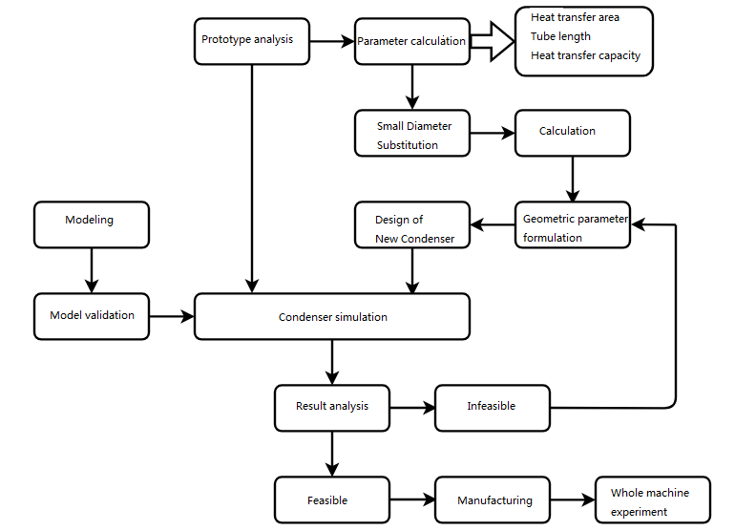

Fig. 1-1 The sketch map of The design on Ф 5 mm small diameter condenser

First according to the Shanghai ocean Nakano cold machine co. LTD., provide the existing big diameter condenser (prototype) to calculate the parameters of the prototype model, extract the prototype of the copper pipe length, spacing and the structural parameters of the fin, prototype is obtained by secondary calculation of coefficient of heat exchange area and wing, combined with the existing heat transfer model, calculate the heat transfer under the rated power, through the accounting of original data as the basic parameter of the new heat exchanger design.

Second, use Ф 9.52 mm copper tube 5 mm brass instead of study, in order to ensure the new condenser heat transfer, heat exchanger heat transfer area needs to be designed. The basic parameters of the new heat exchanger, such as pipe length, heat transfer area and fin structure, can be worked out by calculation. Due to the flow of the refrigerant in the heat exchanger process is complicated, simple guarantee is not the only index does not decrease in heat, if the refrigerant frictional pressure drop loss in the heat exchanger is too big, still can bring poor refrigeration system performance and energy loss is too big, so we must to design flow to balance the pipe diameter decreases the pressure drop rising. Numerical simulation software with the help of the heat exchanger coil - phase change of the designer to simulate the real process flow, and the establishment of simulation model is based on the previous single tube experiment results, combined with the basic principles of condenser design, the design of the small diameter of the condenser and the prototype compares the simulation result, and repeat this step can filter out small diameter condenser model is more reasonable. This is used as a model for further research.

Finally, the theoretical design of small tube diameter condenser performance must be based on the performance test of the overall cooling system can be verified. Therefore, the refrigeration performance of the original system is compared with that of the new system to test the effect of the new condenser on the performance of the refrigerated display cabinet.

## 1.2 Sample analysis of large tube diameter condenser

The first step is to analyze the basic parameters of the larger diameter condenser (prototype) provided by the manufacturer. The structure diagram of the prototype provided by the manufacturer is shown in figure 1-2 and 1-3:

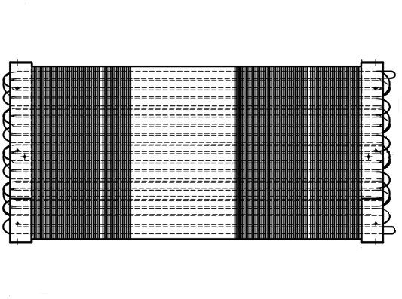

Fig. 1-2 Front view of condenser prototype

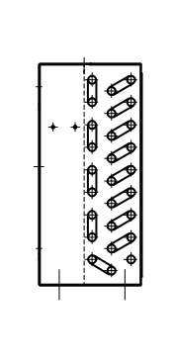 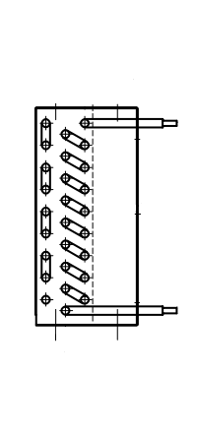

Fig. 1-3 Side view of condenser prototype

According to the structure design of the prototype, some basic geometric parameters can be obtained. In order to obtain further design parameters, such as the heat transfer area of the condenser, it is necessary to calculate them through secondary calculation. Firstly, the outer area of the main pipe per meter length of copper pipe is calculated according to the structural parameters of fins. The area of this part consists of two parts.

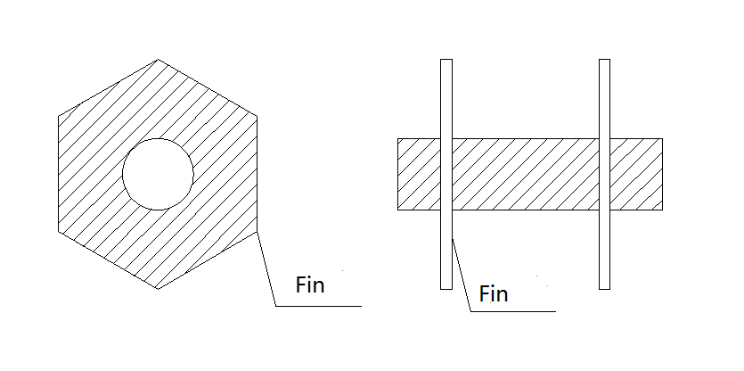

Fig. 1-4 Schematic diagram of total outer area of copper tube per meter long tube

The calculation method is shown in equation (6):

 (6)

S*1*And S*2*——The row spacing of finned tube heat exchanger is shown in figure 1-5，m；*sf* ——fin spacing, m; *d0*-- outer diameter of finned tube base tube, m;

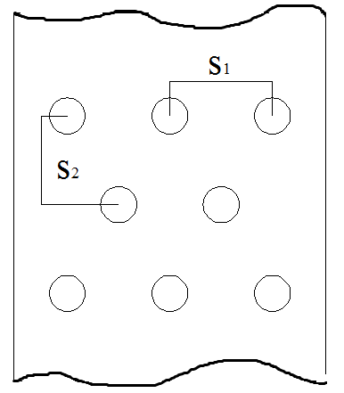

Fig.1-5 Space between rows and columns

Secondly, calculate the outer wall area without fin thickness outside a single tube (tube area between the long fin tubes per meter), as shown in figure 1-5.The calculation method is as follows:

 (7)

*δf* ——fin thickness, m;

Therefore, the total external area per meter of pipe length is:

 (8)

Then multiply the total external area of copper tube per meter with the main pipe length to get the heat transfer area of the condenser.

 (9)

The heat transfer area thus obtained can also be checked by the following equation (10) :

 (10)

Where, *Q*——given heat exchange (converted by rated power of compressor), W; *K*——total heat transfer coefficient of condenser*,* W/ (m2·K); Δ*t*m—— logarithmic average heat transfer temperature difference of the condenser, K.

Finally, a working condition of the refrigeration system was developed according to the research object, which was used to determine the system parameters of evaporation temperature, condensation temperature, superheat, etc., so as to calculate the logarithmic average heat transfer temperature difference of the condenser, as shown in equation (11).In addition, p-h diagram of the refrigeration cycle can be drawn on the pressure-enthalpy diagram, and parameters such as mass flow of refrigerant required by the theory can be calculated.

 (11)

The heat transfer coefficient of the original condenser can be calculated by referring to the calculation method of the air side in the book design of small refrigeration device. On the inside of the tube, the process of phase change heat transfer of working medium is complicated, and the heat resistance of the condenser mainly exists outside the tube. Therefore, the heat transfer coefficient on the inside of the tube can be roughly calculated through the basic internal heat transfer correlation formula, and the total heat transfer coefficient of the condenser can be finally obtained, as shown in equation (12).

 (12)

Where, is the heat transfer coefficient outside the pipe, W/(m2K.);

-- Heat transfer coefficient inside the tube, W/(m2K.);

——finalization coefficient (calculated according to the geometrical parameters of fins);

——Surface efficiency of fin of condenser;

——Air side dirt thermal resistance, (m2K.)/W;

—— Thermal conductivity of red copper pipe, 393 W /(m·K);

—— Tube wall thickness, m.

After checking and calculation, the heat transfer area required by the theoretical calculation of the practical condenser is basically consistent with the heat transfer area obtained by the geometric method. The detailed parameters of the condenser extracted through the prototype analysis are shown in table 1-1.

Table 1-1 structure parameters of prototype are summarized

|  |  |  |  |
| --- | --- | --- | --- |
| Classification | The name of the | Data | Unit |
| Geometry | 3×9 |  |  |
| The length | 535.7 | mm |
| The thickness  The height | 64 | mm |
|  | 245.3 | mm |
| Tube structure | Tube diameter | 9.52 | mm |
| Tube wall thickness | 0.35 | mm |
| Single length | 450 | mm |
| Main long | 12.74 | m |
| The column spacing | 21.65 | mm |
| Row spacing | 25 | mm |
| Fin (AL) | The thickness of the fin | 0.115 | mm |
| Fin spacing | 2.7 | mm |
| Fin height | 236 | mm |
| Fin width | 64 | mm |
| Heat transfer area | Total external area per meter of tube length | 0.38 | m2/m |
| Heat transfer area | 4.79 | m2 |
| Check heat transfer area | 4.68 | m2 |

## 1.3 Design parameters determination of small tube diameter condenser

In order to ensure the original heat transfer capacity of 5mm small-diameter condenser after replacing the original condenser, design and analysis were conducted based on heat transfer calculation formula (13).

 (13)

The above theoretical calculation formula shows that the logarithmic average temperature difference depends on the operation condition of the selected refrigeration device and the working condition of the refrigeration system, while the heat transfer coefficient between the original prototype and the new design heat exchanger is quite different due to the differences in pipe diameter and structure. The difference is mainly reflected in the flow heat transfer inside the tube. As the tube diameter decreases, the liquid film in the tube is thinner and the heat transfer resistance is greatly reduced. Therefore, compared with the original prototype, the heat transfer coefficient inside the tube of the new small-diameter heat exchanger is greatly increased. For the outside of the tube, due to the compact arrangement of the tube, the fin spacing should be correspondingly reduced, the air velocity and turbulence increase, so the corresponding heat transfer coefficient of the outside of the tube is strengthened. But consider the actual use environment of refrigerated display cabinets generally for shopping malls, vegetable farms and other densely populated areas, dust, oil density will be more than the general place to increase a lot, condenser ash speed will become faster. Compared with the ordinary air conditioner, the surface dirt of the condenser will be more in the long-term use. When there is a lot of dust and oil in the gap of the condenser, the heat transfer performance of the condenser will be seriously affected, and the whole performance of the whole refrigeration system will be affected. Therefore, combined with the actual equipment operating environment, the spacing between rows and rows of small-diameter condenser and the spacing between fins should not be too small, so as to slow down the scaling rate of the condenser and maintain the heat transfer performance of the condenser in long-term operation.

At the same time, since the heat transfer area and heat transfer coefficient in the theoretical formula are coupled with each other, the determination of the structural parameters needs to check the heat transfer area to calculate the heat transfer area of the small-diameter condenser, and take this value as a reference standard to guide the calculation of the pipe length and other parameters of the new heat exchanger. Through the design and calculation, Ф 5 mm small diameter condenser of geometric parameters are shown in table 1-2 in detail.

Table 1-2 design geometric parameters of small tube diameter condenser

|  |  |  |  |
| --- | --- | --- | --- |
| Classification | The name of the | Data | Unit |
| Fin parameters | The thickness of the fin | 0.105 | mm |
| Fin spacing | 2.7 | mm |
| Heat transfer area | Total external area per meter of tube length | 0.23 | m2 |
| Heat transfer area | 5.39 | m2 |
| Tube structure | Tube diameter | 5 | mm |
| Tube wall thickness | 0.2 | mm |
| Main long | 23.1 | m |
| The column spacing | 21.65 | mm |
| Row spacing | 25 | mm |

# Chapter II Numerical simulation and design verification

Current condensation during design development relies mainly on the experiment on the design of processing condenser performance testing, and then through the experiment data to continuously adjust the length of each branch of the process, so cycle, greatly increase the development cycle and cost, and with the actual unit is poor, the accuracy of the matching of the coefficient of heat transfer in real applications it is difficult to give full play to the potential of heat exchanger. With the progress of simulation technology, research and development of the new heat exchanger ideal method is based on the HXSim software of heat exchanger, according to the simulation of wind speed distribution on the surface of heat exchanger, heat exchanger to actual running environment, obtain the inside of the tube are calculated in the heat of the pressure drop and flow, so as to provide numerical basis for heat exchanger structure design.

In this project, the simulation calculation method for small-diameter heat exchanger is the heat transfer unit number method, which divides the heat exchange tube of the condenser into independent and uniform small calculation units along the axial direction, as shown in figure 2-1.The heat transfer process is solved one by one along the direction of refrigerant flow in the tube.

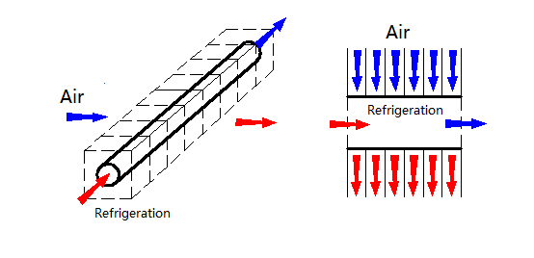

Fig. 2-1 Schematic diagram of calculation model for condenser

Each small calculation unit of the system is solved by the epsilon performance -NTU method. If the epsilon performance and the temperature difference between the refrigerant and the air at the inlet and outlet are known, the actual heat transfer can be calculated according to equation (14) below, and the correct parameter value is input in the simulation software for calculation.

 (14)

Where, —— The actual heat transfer, W; —— Maximum heat transfer, W; —— Efficiency parameters of heat exchanger;——Refrigerant and air inlet temperature, K; —— Mass flow rate of fluid, kg/s; —— Specific heat capacity of the fluid, J/ (kg·K).

## 2.1 Air side heat transfer model

### 2.1.1 Heat transfer coefficient on the air side

In order to strengthen the air side coefficient of heat exchanger, the development of the air boundary layer was adjusted by adjusting the structural parameters of fins, and the enhanced disturbance was realized to enhance heat transfer. The structural parameters of fins have a great influence on the heat transfer coefficient at the air side. In this project, the heat transfer model summarized by Wang et al. is selected for design, as shown in equation (15):

 (15)

According to the different temperature and humidity conditions on the air side of the refrigerated display cabinet, the corresponding j factor correlation formula is selected.

The relational database was taken from 31 experimental samples of Wang et al., and the theoretical model for straight fins was obtained by using multiple regression technique to correlate the test results of experimental samples.

### 2.1.2 Air lateral pressure drop

The pressure drop on the air side of the heat exchanger has a great relationship with the roughness of the fin and the plate structure, and the roughness has a disturbing effect on the air. This project is based on the friction coefficient correlation formula (16~20) summarized by Wang et al.

 (16)

Among them:

 (17)

 (18)

 (19)

 (20)

The symbols of air side correlation are shown in table 2-1

Table 2-1 symbol description of air side correlation formula

|  |  |  |
| --- | --- | --- |
| Symbol | Meaning | Unit |
|  | Minimum circulation area | m2 |
|  | The total surface area | m2 |
|  | Tube surface area | m2 |
|  | The slope of the air saturation curve at the average water film temperature on the outer surface | J/ (kg · K) |
|  | Specific heat of moist air at constant pressure | J/ (kg · K) |
|  | Tube diameter | m |
|  | The hydraulic diameter | m |
|  | Fin spacing | m |
|  | Heat transfer coefficient of wet coil (sensible heat) | W/ (m2·K) |
|  | Total heat transfer coefficient of wet outer surface | W/ (m2·K) |
|  | Reynolds number based on outer diameter of tube | / |
|  | Average condensation film Reynolds number | / |
| Pl | Longitudinal tube spacing | m |
| Pt | Transverse tube spacing | m |

## 2.2 Refrigerant side heat transfer model

Currently, there are few available theoretical models for small pipe diameter heat exchangers, and the existing main theoretical models are still evolving on the basis of the previous models of large pipe diameter. Therefore, this study builds a single-tube test bed for the actual application of heat exchangers, and conducts experimental research on flow condensation in small tube diameter. Finally, according to the experimental results, a heat exchanger design heat transfer model suitable for this study is obtained. Since the basic study of single-tube experimental testing contains many details and the process is complex, this paper will not go into details, please refer to the project summary report for details.

### 2.2.1 Refrigerant side heat transfer coefficient

According to the basic theoretical study of small tube diameter of heat exchanger mentioned above, the refrigerant side heat transfer coefficient model was selected by Shah et al. This correlation formula integrates 547 data points of current mainstream heat transfer research, and is applicable to a wide range of working conditions. See equations (21~26) for details:

 (21)

 (22)

 (23)

 (24)

 (25)

 (26)

### 2.2.2 Refrigerant side pressure drop

The side pressure drop of refrigerant in heat exchanger is an important index to evaluate the performance parameters of heat exchanger. However, the factors affecting the side pressure drop of refrigerant are complex. During heat transfer, the refrigerant in the tube changes phase. When the refrigerant changes from gas phase to liquid phase, there is momentum pressure drop with the change of kinetic energy of working medium. According to the fitness verification of the heat transfer model mentioned above, the two-phase frictional pressure drop model of the working medium adopts the correlation equation proposed by Miyara A et al., as shown in equation (27~29).The calculation of physical property parameters in the above model is obtained by software.

 (27)

 (28)

 (29)

The symbol description of refrigerant side correlation formula is shown in table 2-2

Table 2-2 description of air side correlation symbols

|  |  |  |
| --- | --- | --- |
| Symbol | Meaning | Unit |
|  | Tube diameter | m |
|  | Mass flow rate | Kg/(m2·S) |
|  | Acceleration of gravity | M/s2 |
|  | Heat transfer coefficient | W/(m2·K) |
|  | Liquid phase heat transfer coefficient | W/(m2·K) |
|  | Total heat transfer coefficient | W/(m2·K) |
|  | Heat transfer coefficient | W/(m2·K) |
|  | Two dimensional steam velocity | / |
|  | Thermal conductivity | W/(m·K) |
|  | The pressure drop | Pa |
|  | Plante number | / |
|  | Vapor quality | / |
|  | Dynamic viscosity | Pa s. |
|  | The density of | Kg/m3 |
|  | Liquid Reynolds number | / |
|  | General Reynolds number | / |
|  | Number of boiling | / |
|  | Froude number | / |
|  | Martinelli's number | / |
|  | Friction pressure drop | Pa |

## 2.3 model reliability verification

In order to verify the correctness and reliability of the numerical calculation model, the experimental samples of the original large-diameter condenser were simulated numerically. The calculation results are shown in figure 2-2.

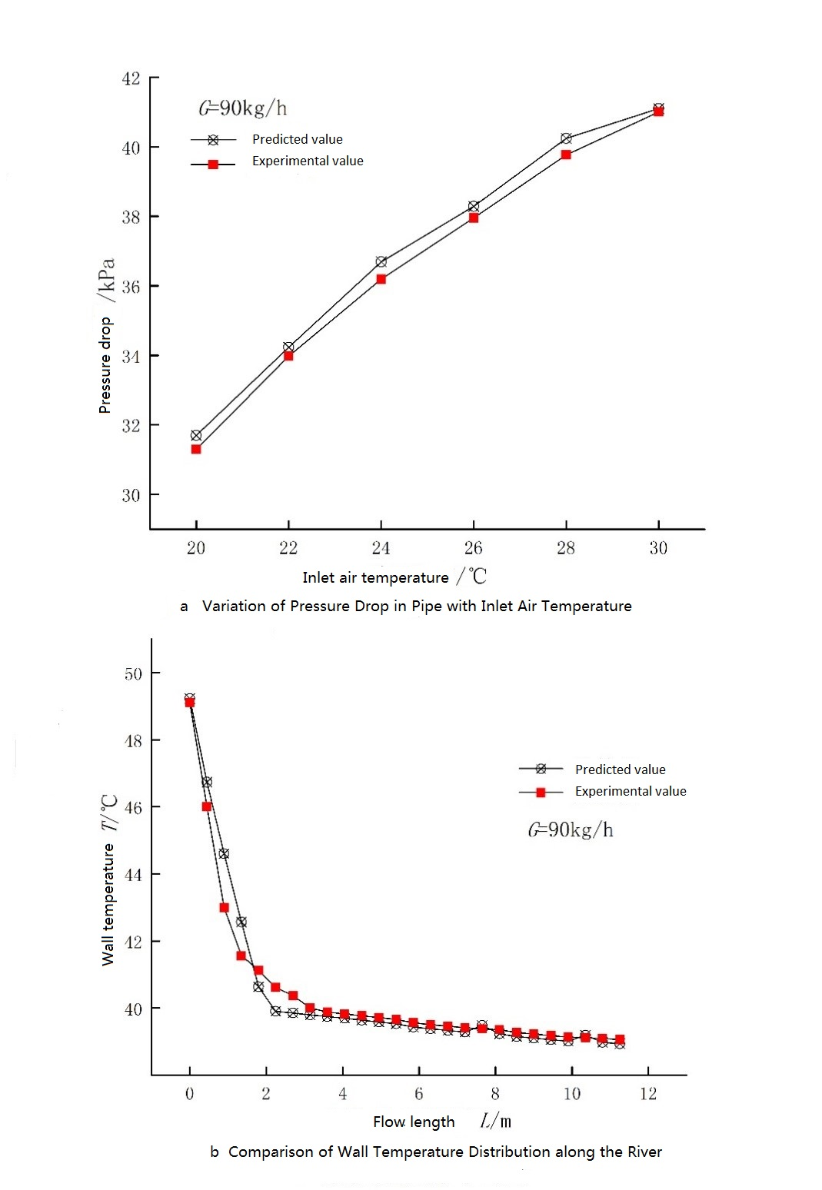

Figure 2-2 comparison between the calculated results of condenser and the experimental results

As can be seen from the figure, for the pressure drop, the deviation between the experimental value and the calculated value is very small; For the wall temperature of the pipe, except that some points are affected by the reverse heat conduction of the front and back pipes, and the calculated values are slightly different from the experimental values, the pressure drop and heat transfer in other places are good, indicating that the calculation model has a high reliability.

# Chapter III Design of small tube diameter condenser flow path

Reasonable design of heat exchanger flow path can make all parts of the heat exchanger get higher heat transfer coefficient and ensure better heat transfer performance when the pressure drop is reasonable. At the same time, better flow design will make the refrigerant flow and heat transfer uniform. The research on the structure design of small tube diameter condenser is the key point of this project. In this section, by means of software numerical simulation and combining with the design principles of condenser, the calculated parameters in the above chapter are used as the design basis to design and develop a batch of small-diameter condenser for refrigerating display cabinet that replaces the original prototype.

## 3.1 condenser flow design

The condenser must control the mass flow rate of refrigerant in the tube through the shunt, so as to avoid the loss of friction pressure drop caused by excessive mass flow rate. According to the research of S.Y. Liang and T.N. Wong, it can be concluded that with the increase of mass velocity in the tube, the heat transfer per unit area first increases and then decreases, and the change has an optimal value. Therefore, it is necessary to carry out reasonable shunt design for heat exchanger to control the mass velocity. Heat flux varies with mass velocity under different flow path structures, as shown in figure 3-1.

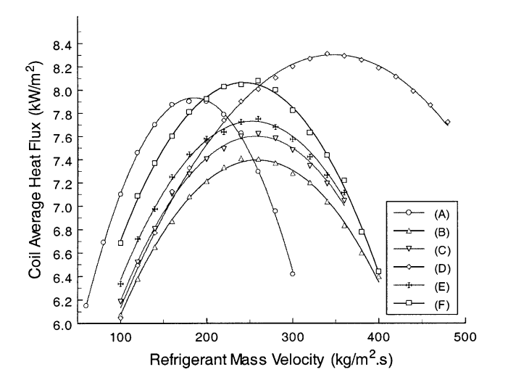

Fig. 3-1 Average heat flux with refrigerant mass velocity for marketers configurations

At the same time, the flow uniformity of working medium in different branches has a great impact on the performance of the condenser. In addition to the design of flow design and resistance design, the other core work is to optimize the design of refrigerant flow and achieve uniform liquid distribution in the heat exchange process. The design of condenser flow path includes not only the arrangement of heat exchange tubes, but also the bifurcation and convergence flow of heat exchange tubes. When the refrigerant flow rate is constant, the number of branches, whether bifurcation and convergence will directly affect the refrigerant flow rate, and thus indirectly affect the heat transfer coefficient. Improper design of the flow path will lead to the phenomenon of liquid accumulation in the condenser or uneven distribution of refrigerant flow in different branches, which will cause the heat transfer area cannot be effectively and fully utilized, and the heat transfer coefficient and heat transfer efficiency will be affected.

In addition, the design of the flow path will also affect the flow heat transfer between refrigerant and external medium. The structure of the flow path will have a great influence on the logarithmic average temperature difference in the heat transfer process, thereby affecting the heat transfer coefficient. In order to obtain higher heat transfer coefficient, the reasonable connection mode of tube group should make the best comprehensive effect of the two. Therefore, this project adopts the domestic and foreign academic achievements of pipeline design and experimental verification results as the technical reference for comprehensive analysis.

## 3.1.1 Flow forms of refrigerant in tube and air outside tube

Shen conducted experimental research on the design of down-flow and down-flow pipelines of the condenser using R407C refrigerant. With the same two rows of condenser, the heat transfer efficiency is 36% higher than that with the same two rows of condenser. The heat transfer efficiency of three - row condenser is increased by 50%.Moreover, as the number of tubes increases, it becomes easier for the refrigerant and air to approach the true pure countercurrent, and the greater the increase in heat transfer capacity. The basic principle is that the countercurrent arrangement increases the logarithmic average temperature difference of the heat exchanger and enhances the heat transfer effect.

### 3.1.2 Condenser inlet and outlet layout

In view of the condenser's function is to condense high temperature and high pressure gaseous working medium into liquid refrigerant, which is the working state of gas inlet and liquid outlet. Considering the factors of gravity, it is beneficial to the circulation of working medium to place the inlet higher than the outlet, so as to avoid the adverse effect of gravity on heat exchange effect. At the same time, the experimental study on the flow path of the condenser shows that the inlet and outlet of different surface branches should be as close as possible, and the inlet and outlet should be as far as possible, so as to avoid the loss of heat exchange due to reheating.

### 3.1.3 Pipe layout and pipe parting

In order to obtain uniform resistance in each flow path, the pipe path of different flow paths should be the same and flow through windward and leeward sides evenly to make heat transfer uniform. The uniformity of pipeline distribution can ensure the uniformity of refrigerant heat transfer in different channels, but the premise is that the wind speed on the surface of the heat exchanger is evenly distributed. It is inevitable that there will be uneven distribution of the wind speed in the face of the upwind and upwind condenser. The condenser in the refrigerated display cabinet studied in this project belongs to the side-out air condenser, and its head-on wind speed is relatively uniform. Therefore, in the design of the flow path of small tube diameter condenser, the design is carried out according to the principle of average pipe length.

In addition to the principle of pipe length distribution, the appropriate points can also enhance the heat transfer effect. Existing studies have optimized the condenser flow with double exhaust intersections. The double exhaust flow is combined in the second half of the process, and after improvement, the overall heat transfer and pressure drop distribution of the condenser are more uniform. In particular, the heat transfer coefficient in the second half is greatly increased, but the increase of pressure drop is not significant. The simulation results show that for this structure condenser, the junction point of the branch in the second half should be at the beginning of the super-cooled section. For the condenser inlet superheated section, because the proportion of the tube length is small, the influence on heat transfer is small. For the second half of the condenser (including two phase zone during the second half and super-cooling section), with the thickening of condensate, the average density of two-phase fluid inside in growing, average flow velocity will be falling, causing the deterioration of heat transfer, if in the second half will be two way and all the way (double into single out), due to the cross-sectional area is reduced, the average flow rate will increase, which can strengthen the refrigerant vapor relatively liquid phase perturbation, enhanced heat transfer effect. Overall, heat transfer uniformity becomes better, pressure drop and heat transfer are balanced, and tube consumption is reduced.

YE H.Y. et al. studied the specific location of the merging point of the condenser based on the principle of minimum entropy increase, and the object of study was the complex six-row multi-pass condenser. In this study, the number of condenser flow was firstly optimized, and then the calculation showed that the optimal number of condenser flow was gradually reduced with the change of gas-two-phase and liquid-phase, and the merging point of the flow was in the two-phase region, and its dryness was about 0.3.

Based on the above research conclusion, sure this topic Ф 5 mm diameter condenser design, scheme is as follows:

1) Countercurrent heat transfer is adopted between the condenser refrigerant and the outside air to improve the logarithmic average temperature difference and enhance the heat transfer effect;

2) The inlet of the condenser branch is higher than the outlet to avoid the adverse effect of gravity on heat exchange;

3) The exits and entrances of different branches are close to each other and keep away from each other as far as possible to avoid the loss of heat exchange due to reheating;

4) Different pipe lengths of the shunt should be kept the same, so as to ensure uniform heat transfer of different channels;

5) Parallel tube treatment can be carried out on the second half of condenser branch to improve its overall heat transfer uniformity and meet the comprehensive performance requirements of condenser heat transfer and pressure drop.

## 3.3 Design and simulation of small tube diameter condenser flow path

Before actually making different condensers and conducting experiments to study the distribution of condenser flow path, this project used HXSim software to simulate and simulate the condenser, and obtained heat transfer trends in different working conditions, thus simplifying each design problem. Firstly, the operating condition of the condenser is controlled and the simulation results of the small-tube-diameter condenser are compared with the results of the prototype to judge whether the designed new heat exchanger maintains the basic heat transfer capacity. At the same time, comparing the calculation results of different new heat exchanger models, the condenser structure with basic heat transfer capacity and better heat transfer performance can be screened out.

Before the simulation of condenser, according to the actual operation of the refrigerated display cabinet, the test scope of the refrigerated display cabinet is referred to in the national standard, and the calculation conditions of the simulation are formulated according to the operating parameters of the refrigeration system. The aim is to simulate the real environment of refrigerated display cabinet and exclude the influence of other factors. The calculation conditions are shown in table 3-1:

Table 3-1 condenser calculation conditions

|  |  |
| --- | --- |
| Parameter | The numerical |
| Working medium | R404A |
| Air speed | 2.89 m/s |
| Air inlet dry bulb temperature | 25 ℃ |
| Relative humidity of air inlet | 60% |
| The atmospheric pressure | 101.3 kPa |
| Refrigerant inlet pressure | 1815.7 kPa |
| Refrigerant flow | 0.028 kg/s |

As shown in figure 3-2 for refrigerated display cabinets Ф actual condenser flow distribution is 9.52 mm, its detailed structure parameters as shown in table 3-2.Using the aforementioned calculation model, the prototype is simulated. The calculated results are shown in table 3-3.

Table 3-2 Ф 9.52 mm condenser structure parameters

|  |  |
| --- | --- |
| Parameter | The numerical |
| Single length | 450 mm |
| Tube diameter | The 9.52 mm |
| The column spacing | The 21.65 mm |
| Row spacing | 25 mm |
| Number of heat exchange tube | 26 |

图示

Fig 3-2 Ф 9.52 mm condenser circuit

Table 3-3 simulation results of prototype

|  |  |
| --- | --- |
| Parameter | Ф 9.52 mm |
| Air outlet temperature /℃ | 31 |
| Heat exchange in the condenser / W | 2247.69 |
| Refrigerant pressure drop /kPa | 41.96 |
| Air side pressure drop /Pa | 48.52 |

In the design of new type heat exchanger, it is necessary to consider not only the heat transfer performance of condenser, but also to the processing and installation of the condenser, practice, if the new condenser height or width is too large, occupy too much space, the refrigeration system of other devices or refrigerated cabinets installation cause congestion, go against the use of refrigerated display cabinets. Therefore, in the design of the new heat exchanger, try to keep the small tube diameter condenser and prototype windward area consistent, do not affect the original refrigerated display cabinet overall structure. The following further elaborated the different flow path design scheme.

### 3.3.1 Circuit design of 5 mm Ф condenser with 52 tubes

On the calculated Ф small diameter 5 mm minimum main condenser is 23.1 m long, keep the width of the condenser is changeless, is still single tube length is 450 mm, the heat exchange tube bundle of at least 52 root. As far as possible in order to make the height of condenser is small, due to the column spacing is known, will therefore Ф condenser is set to 4 x 5 mm tube arrangement of 13.At this time, it is found that the 13 primes cannot be evenly distributed. According to the principle of uniform distribution of tube path designed by the condenser mentioned above, a tube arrangement of 4×14 is set. Since the sectional area of the branch is smaller after the tube diameter is reduced, the number of corresponding branches of the small-tube diameter condenser is increased to reduce the refrigerant velocity and pressure drop of each branch. In order to ensure the uniformity of pipeline distribution, the flow scheme of 4×14 pipe arrangement is set as A1 and A2 (see figure 3-3).

Table 3-4 simulation results of group A

|  |  |  |  |
| --- | --- | --- | --- |
| Parameter | Ф 9.52 mm | A1 | A2 |
| Single tube length /mm | 450 | 450 | 450 |
| Air outlet temperature /℃ | 31 | 32.4 | 32.16 |
| Heat exchange in the condenser per W | 2247.69 | 2843.89 | 2768.83 |
| Refrigerant pressure drop /kPa | 41.96 | 27.64 | 5.49 |

**A1 A2**

Fig 3-3 Circuit design of 5 mm Ф condenser with 52 tubes

Fig. 3-4 Simulation of condenser Ф 5 mm in group A

The calculation results of pressure drop of heat exchanger are shown in table 3-4. The refrigerant pressure drop is obviously affected by flow layout, and increasing the number of branches can effectively suppress the increase of pressure drop. For example, a large number of A2 branches make the refrigerant pressure drop very small. However, the heat exchange of the condenser is affected due to the decrease of the working medium's velocity in the tube. Although the heat exchange of the two kinds of tube condenser is higher than that of the prototype, the increased heat exchange is not very high. Taken together, the two heat transfer ability were higher than 9.52 mm Ф condenser heat transfer capability, but small diameter condenser heat transfer performance and the rising space. Therefore, on this basis, the heat transfer tube bundle design continues to increase, to increase the heat transfer area.

### 3.3.2 Circuit design of the 5 mm condenser with 60 tubes

In order to ensure the original Ф 9.52 mm heat transfer performance of condenser, consider increase heat exchange area of allowance, so the number increase heat exchange tube is 60.According to the design ideas mentioned above and the basic principles of condenser design, three designs of 60 heat exchange tubes, B1 and B2, are proposed (see figure 3-5). The single tube length is still 450mm, and the tube bundle arrangement is 5×12.

The calculation results are shown in table 3-5. It can be seen from the calculation that the heat transfer capacity of the small-diameter condenser increased significantly after the heat exchange tube was added, and the pressure drop measured by the refrigerant was also controlled below the pressure drop of the prototype. B3 has a low heat transfer rate, which is caused by too many branches, resulting in too low mass flow rate and poor heat transfer effect in the tube. Although B2 and B1 are divided into four branches, B2 is divided and combined in the second half of the pipeline, which is conducive to the utilization of heat transfer area. Compared with B1, heat transfer is significantly improved, and pressure drop is also within a controllable range.

B1 B2 B3

Fig. 3-5 Circuit design of the 5 mm condenser with 60 tubes

Fig 3-6 Simulation of 5 mm condenser in group B

Table 3-5 simulation results of group B

|  |  |  |  |  |
| --- | --- | --- | --- | --- |
| Parameter | Φ 9.52 mm | B1 | B2 | B3 |
| Single tube length /mm | 450 | 450 | 450 | 450 |
| Air outlet temperature /℃ | 31 | 33.15 | 33.19 | 32.78 |
| Heat exchange in the condenser per W | 2247.69 | 3058.29 | 3071.29 | 2921.65 |
| Refrigerant pressure drop /kPa | 41.96 | 29.82 | 32.46 | 9.13 |

### 3.3.3 Circuit design of 5 mm condenser tubes for 420 mm length

5 mm small diameter Ф condenser, meanwhile, are there any other way of arrangement. Considering the increase of the number of branches, the refrigerant flow in each branch decreases correspondingly, and it is likely to have excess heat exchange area in the second half of branches. Therefore, the length of single tube for heat exchange of condenser is appropriately reduced, and the utilization rate of heat exchange area is improved by increasing the number of heat exchange pipes. Now, the length of a single tube is reduced to 420mm, and 4×15 and 4×16 flow paths are designed. Therefore, three schemes of C1, C2 and C3 are proposed (figure 3-7). The simulation results are shown in table 3-6.

The calculation results show that the heat transfer of the three models in group C is greatly improved compared with the prototype. Compared with C2 and C3, C1 has a slight decrease in heat transfer, but its advantages are also obvious, and its volume and pressure drop are the lowest among the three. Comparing group C with group B, it is found that after the length of single tube of heat exchange tube decreases, the heat exchange can still reach the design goal after reasonable flow design, and the pressure drop can also be balanced by adding branches and branches.

Table 3-6 simulation results of prototype

|  |  |  |  |  |
| --- | --- | --- | --- | --- |
| Parameter | Φ 9.52 mm | C1 | C2 | C3 |
| Single tube length /mm | 450 | 420 | 420 | 420 |
| Air outlet temperature /℃ | 31 | 33 | 33.19 | 32.78 |
| Heat exchange in the condenser per W | 2247.69 | 3000.55 | 3052.39 | 3063.95 |
| Refrigerant pressure drop /kPa | 41.96 | 15.56 | 30.18 | 32.41 |

C1 C2 C

Fig 3-7 Circuit design of 5 mm condenser tubes for 420 mm length

卡通人物

低可信度描述已自动生成 黑白色的标志

Fig 3-8 Simulation of 5 mm Ф condenser in group C

## 3.4 Performance comparison of different structures

Through the heat exchange of the different structure design can be A, B, C Ф 5 mm small diameter of three groups of different condenser simulation calculation results are shown in table 3 to 7. All the eight models have higher heat exchange capacity than the condenser of the original refrigerated cabinet, and the pressure drop is lower than the condenser of the original refrigerated cabinet. Theoretical research shows that the heat exchange performance of all the new heat exchangers is better than the original condenser of the original refrigerated cabinet. However, in order to compare the heat transfer performance of all models with small pipe diameter more clearly, the heat transfer area of all models is listed in table 3-7, and then heat transfer per unit area and pressure drop per unit area are introduced for auxiliary analysis.

According to the analysis of heat transfer per unit area, A2 and B3 have the lowest heat transfer of all models, which is related to their too many branches, which make the flow rate lower and reduce the heat transfer. Although the pressure drop per unit area is very low, heat transfer is the most basic parameter to measure the performance of heat exchanger, so it is selected out. The pressure drop per unit area of B2 and C3 is too high, because they are combined in the second half of the branch, which leads to the increased flow rate of working medium in the second half of the branch, slightly increasing the pressure drop. However, due to the increased utilization rate of heat transfer area, heat transfer per unit area is also the highest among all models. Generally speaking, this "double-single" arrangement has the best comprehensive performance (i.e. lower pressure drop and higher heat transfer) after selecting the appropriate points of separation and closure. It can make the heat transfer of the whole process tend to be uniform, thus improving the comprehensive performance of the heat exchanger. Finally, four types of small tube diameter condenser (B1, B2, C1 and C3) are selected as the final models of small tube diameter condenser design.

Table 3-7 summary of simulation results of prototype

|  |  |  |  |  |  |  |  |  |
| --- | --- | --- | --- | --- | --- | --- | --- | --- |
| Parameter | A1 | A2 | B1 | B2 | B3 | C1 | C2 | C3 |
| Single tube length /mm | 450 | 450 | 450 | 450 | 450 | 420 | 420 | 420 |
| Heat transfer/W | 2843.89 | 2768.83 | 3058.29 | 3071.29 | 2921.65 | 3000.55 | 3052.39 | 3063.95 |
| Refrigerant pressure drop /kPa | 27.64 | 5.49 | 29.82 | 32.46 | 9.13 | 15.56 | 30.18 | 32.41 |
| Heat transfer area per m2 | 5.88 | 5.88 | 6.3 | 6.3 | 6.3 | 6.3 | 6.27 | 6.27 |
| Heat transfer per unit area /W/m2 | 483.65 | 470.89 | 485.44 | 487.5 | 463.75 | 476.28 | 486.82 | 488.67 |
| Pressure drop per unit area/kPa/m2 | 4.7 | 0.93 | 4.73 | 5.15 | 1.45 | 2.47 | 4.81 | 5.17 |

To sum up, after the preliminary design and combined with HXSim software simulation, determine the four different Φ 5 mm small diameter condenser model. The four Φ 5 mm small diameter in the condenser heat transfer single pipe length, volume, number of branch and flow structure are different, in order to be able to before on the experiment, the condenser heat transfer properties of different have a preliminary understanding, and to analyze advantages and defects of different flow condenser, and the cause of defect, to be well prepared for the whole experiment, subsequent analysis of the performance of different working conditions.

Table 3-8 performance parameters of selected models

|  |  |  |  |
| --- | --- | --- | --- |
| Models | Single pipe length | Heat transfer lift | The pressure drop reduction |
| B1 | 450 mm | 36.06% | 28.93% |
| C3 | 420 mm | 36.32% | 22.76% |
| C1 | 420 mm | 33.49% | 62.92% |
| B2 | 450 mm | 36.64% | 22.64% |
| On average, | / | 35.63% | 34.31% |

## 3.5 Processing drawings of small diameter condenser prototype

Finally, after determining four different types of small diameter Ф5mm condenser, draw the two-dimensional processing map of heat exchanger and carry out the production and processing of manufacturers. Figure 3-9 is the TWO-DIMENSIONAL processing drawing of C1 model. See Figure 3-10 for the physical photo.

Fig 3-9 TWO-DIMENSIONAL processing drawing of C1

Fig 3-10 Photo of prototype C1

# Reference

1. 杨世铭, 陶文铨. 传热学. 第四版. 北京：高教出版社.
2. 丁炜堃, 邓斌, 陶文铨. 小管径空调冷凝器数值模拟及流路设计[J]. 工程热物理学报, 2009, 30(8):1389-1392.
3. Shah M M. A general correlation for heat transfer during film condensation inside pipes [J]. International Journal of Heat & Mass Transfer, 1979, 22(4):547-556.
4. 王婷婷, 任滔, 丁国良,等. 小管径空调器的优化设计[J]. 制冷技术, 2012(4).
5. 肖彪. 翅片管式换热器制冷剂流路对换热特性影响的实验研究(下)[J]. 家电科技, 2008(23):56-58.
6. 邓斌, 陶文铨, 林澜. 冷凝器流程布置方案的研究与探讨[J]. 制冷学报, 2006, 27(2):31-38.
7. Wang C C, Chi K Y, Chang C J. Heat transfer and friction characteristics of plain fin-and-tube heat exchangers, part II: Correlation [J]. International Journal of Heat & Mass Transfer, 2000, 43(15):2693-2700.
8. Wang C C, Lin Y, Lee C. An airside correlation for plain fin-and-tube heat exchangers in wet conditions [J]. International Journal of Heat & Mass Transfer, 2000, 43(10):1869-1872.
9. Shah M M. A general correlation for heat transfer during film condensation inside pipes [J]. International Journal of Heat & Mass Transfer, 1979, 22(4):547-556.
10. Miyara, A., Kuwahara, K., Koyama, S., 2004. Correlation of frictional pressure loss of two-phase flow including effects of tube diameter and mass velocity. In: Proceedings of JSME, 57th Kyushu Conference No. 048-1, pp. 117–118 (in Japanese).